SYLLABUS

MOBILE APPLICATION DEVELOPMENT

Subject Code: 18CSMP68 IA Marks: 40
No. of Practical Hrs. / Week: 0:0:2 Exam Marks: 60

Total No. of Practical Hrs: 3 Hours/Week Exam Hours: 03 No. of Credits: 02
Descriptions (if any):

- The installation procedure of the Android Studio/Java software must be demonstrated and carried out in groups.
- Students should use the latest version of Android Studio/Java/ Kotlin to execute these programs. Diagrams given are for representational purposes only, students are expected to improvise on them.
- Part B programs should be developed as an application and are to be demonstrated as a mini project in a group by adding extra features or the students can also develop their application and demonstrate it as a mini-project. (Projects/programs are not limited to the list given in Part B).

Program 1

PART A

Create an application to design a Visiting Card. The Visiting card should have a company logo at the top right corner. The company name should be displayed in Capital letters, aligned to the center. Information like the name of the employee, job title, phone number, address, email, fax and the website address is to be displayed. Insert a horizontal line between the job title and the phone number.
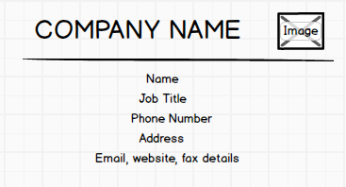

Develop an Android application using controls like Button, TextView, EditText for designing a Calculator having basic functionality like Addition, Subtraction, Multiplication, and Division.
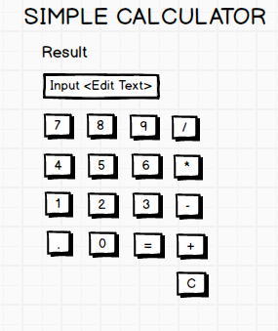

Program 3
Create a SIGN Up activity with Username and Password. Validation of password should happen based on the following rules:
- Password should contain uppercase and lowercase letters.
- Password should contain letters and numbers.
- Password should contain special characters.
- Minimum length of the password (the default value is 8).
On successful SIGN UP proceed to the next Login activity. Here the user should SIGN IN using the Username and Password created during signup activity. If the Username and Password are matched then navigate to the next activity which displays a message saying “Successful Login” or else display a toast message saying “Login Failed”. The user is given only two attempts and after that display a toast message saying “Failed Login Attempts” and disable the SIGN IN button. Use Bundle to transfer information from one activity to another.
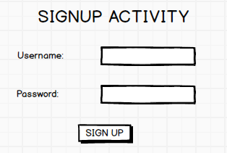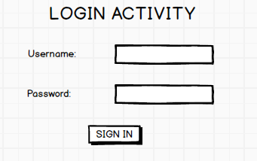

Develop an application to set an image as wallpaper. On click of a button, the wallpaper image should start to change randomly every 30 seconds.
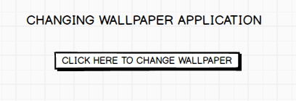

Program 5
Write a program to create an activity with two buttons START and STOP. On Pressing of the START button, the activity must start the counter by displaying the numbers from One and the counter must keep on counting until the STOP button is pressed. Display the counter value in a TextView control.
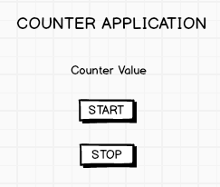

Program 6
Create two files of XML and JSON type with values for City_Name, Latitude, Longitude, Temperature, and Humidity. Develop an application to create an activity with two buttons to parse the XML and JSON files which when clicked should display the data in their respective layouts side by side.
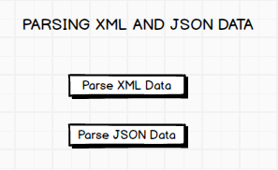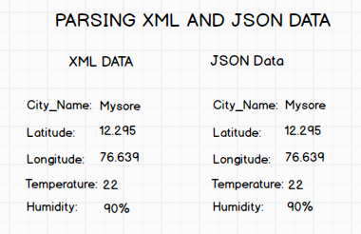

Develop a simple application with one Edit Text so that the user can write some text in it. Create a button called “Convert Text to Speech” that converts the user input text into voice.
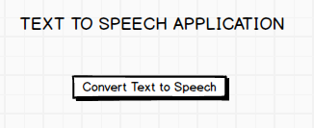

Program 8
Create an activity like a phone dialer with CALL and SAVE buttons. On pressing the CALL button, it must call the phone number and on pressing the SAVE button it must save the number to the phone contacts.
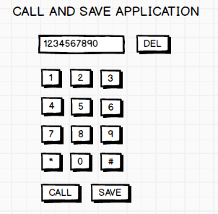

PART B

Program 1
Write a program to enter Medicine Name, Date and Time of the Day as input from the user and store it in the SQLite database. Input for Time of the Day should be either Morning or Afternoon or Evening or Night. Trigger an alarm based on the Date and Time of the Day and display the Medicine Name.
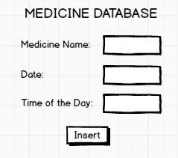

Develop a content provider application with an activity called “Meeting Schedule” which takes Date, Time and Meeting Agenda as input from the user and store this information into the SQLite database. Create another application with an activity called “Meeting Info” having DatePicker control, which on the selection of a date should display the Meeting Agenda information for that particular date, else it should display a toast message saying “No Meeting on this Date”.
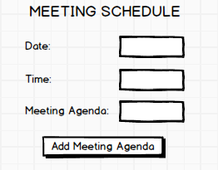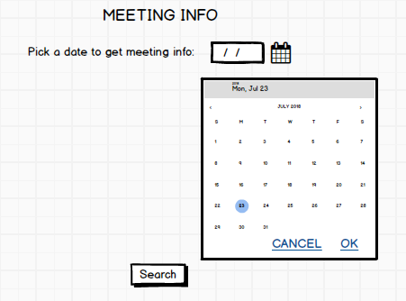

Program 3
Create an application to receive an incoming SMS which is notified to the user. On clicking this SMS notification, the message content and the number should be displayed on the screen. Use appropriate emulator control to send the SMS message to your application.
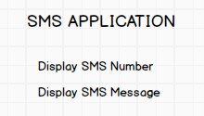

Program 4
Write a program to create an activity having a Text box, and also Save, Open and Create buttons. The user has to write some text in the Text box. On pressing the Create button the text should be saved as a text file in MkSDcard. On subsequent changes to the text, the Save button should be pressed to store the latest content to the same file. On pressing the Open button, it should display the contents from the previously stored files in the Text box. If the user tries to save the contents in the Textbox to a file without creating it, then a toast message has to be displayed saying “FirstCreate a File”.
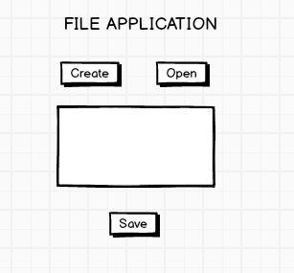

Create an application to demonstrate a basic media player that allows the user to Forward, Backward, Play and Pause an audio. Also, make use of the indicator in the seek bar to move the audio forward or backward as required.
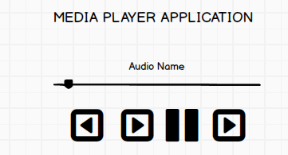

Program 6
Develop an application to demonstrate the use of Asynchronous tasks in android. The asynchronous task should implement the functionality of a simple moving banner. On pressing the Start Task button, the banner message should scroll from right to left. On pressing the Stop Task button, the banner message should stop. Let the banner message be “Demonstration of Asynchronous Task”.
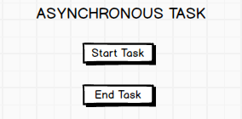

Program 7
Develop an application that makes use of the clipboard framework for copying and pasting of the text. The activity consists of two EditText controls and two Buttons to trigger the copy and paste functionality.
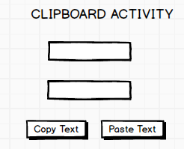

Program 8
Create an AIDL service that calculates Car Loan EMI. The formula to calculate EMI is

E = P * (r(1+r)^{n})/((1+r)^{n}-1)
where
E = The EMI payable on the car loan amount P = The Car loan Principal Amount
r = The interest rate value computed on a monthly basis n = The loan tenure in the form of months
The down payment amount has to be deducted from the principal amount paid towards buying the Car. Develop an application that makes use of this AIDL service to calculate the EMI. This application should have four EditText to read the Principal Amount, Down Payment, Interest Rate, Loan Term (in months) and a button named as “Calculate Monthly EMI”. On click of this button, the result should be shown in a TextView. Also, calculate the EMI by varying the Loan Term and Interest Rate values.
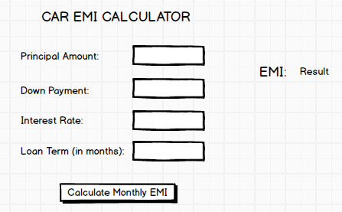

Course Outcomes
After successful completion of the Course, the participants will be able to

18CSMP68.1 | Create, test and debug Android application by setting up Android development  environment.
18CSMP68.2 | Implement adaptive, responsive user interfaces that work across a wide range  of devices.
18CSMP68.3 | Demonstrate methods in storing, sharing and retrieving data in Android  applications.
18CSMP68.4 | Infer the role of permissions and security for Android applications.

CO-PO Mapping

CO No. | PO1 | PO2 | PO3 | PO4 | PO5 | PO6 | PO7 | PO8 | PO9 | PO10 | PO11 | PO12
18CSMP68.1 | 3 | 2 | 2 | - | 2 | 1 | - | - | 1 | 1 | - | 1
18CSMP68.2 | 3 | 2 | 2 | - | 2 | 1 | - | - | 1 | 1 | - | 1
18CSMP68.3 | 3 | 2 | 2 | - | 2 | 1 | - | - | 1 | 1 | - | 1
18CSMP68.4 | 3 | 2 | 2 | - | - | - | - | 2 | 1 | 1 | - | 1

Procedure to Conduct Practical Examination

Experiment distribution
- For laboratories having only one part: Students are allowed to pick one experiment from the lot with equal opportunity.
- For laboratories having PART A and PART B: Students are allowed to pick one experiment from PART A and one experiment from PART B, with equal opportunity.

Change of experiment is allowed only once and marks allotted for procedure to be made zero of the changed part only.

Marks Distribution (Courseed to change in accordance with university regulations)
- For laboratories having only one part –
Procedure + Execution + Viva-Voce: 15+70+15= 100 Marks
- For laboratories having PART A and PART B
  - Part A – Procedure + Execution + Viva = 6 + 28 + 6 = 40 Marks
  - Part B – Procedure + Execution + Viva = 9 + 42 + 9 = 60 Marks

Android Studio Tutorials

Install Android Studio and Packages:

Download Android Version 4.0.2 from the below link
https://anaconda.com

Configure Android SDK packages:

Go to Tools → SDK Manager
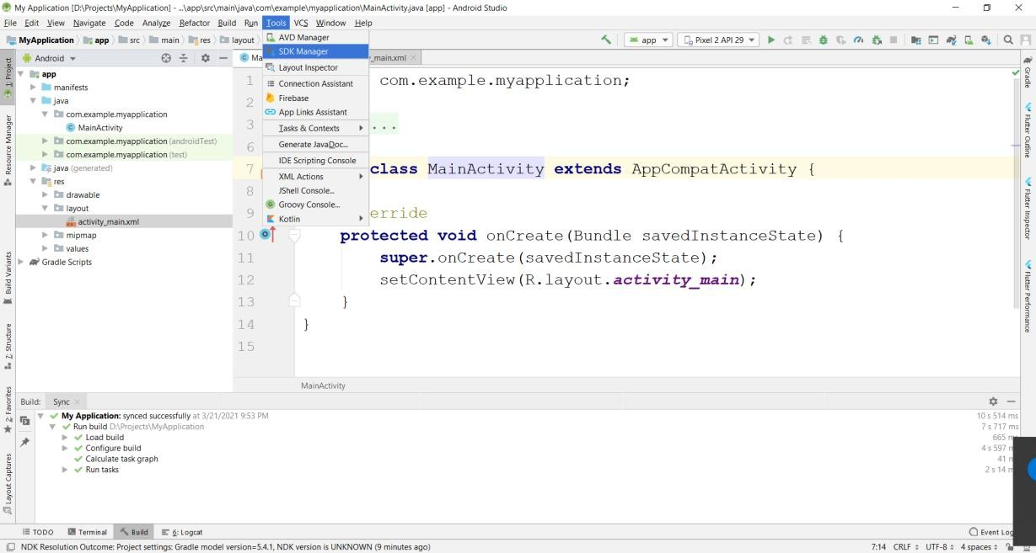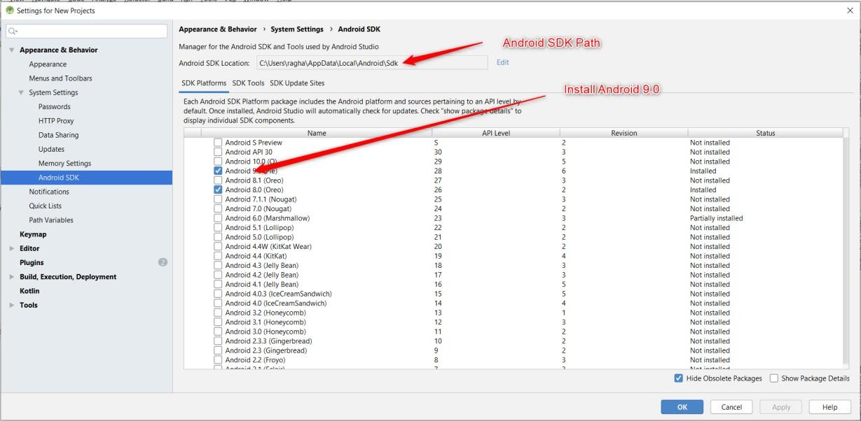

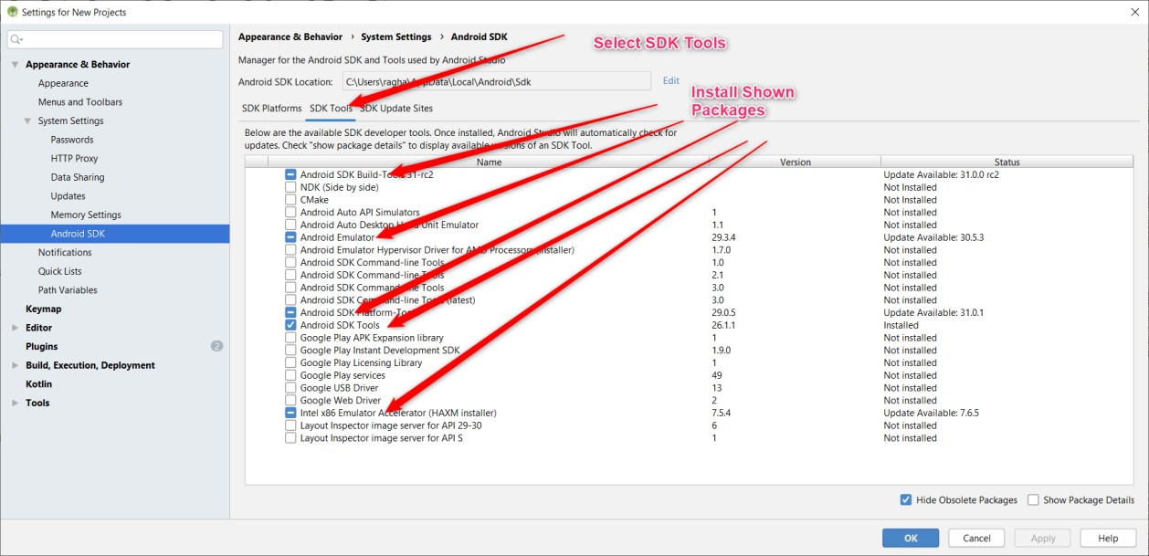

  - Creating Emulator

Go to Tools → Select AVD Manager
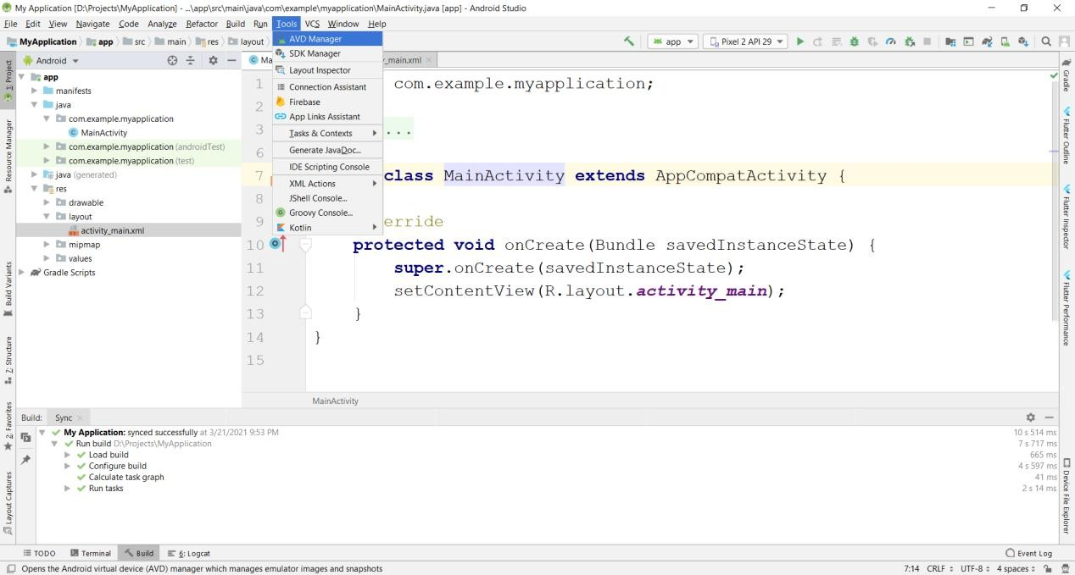

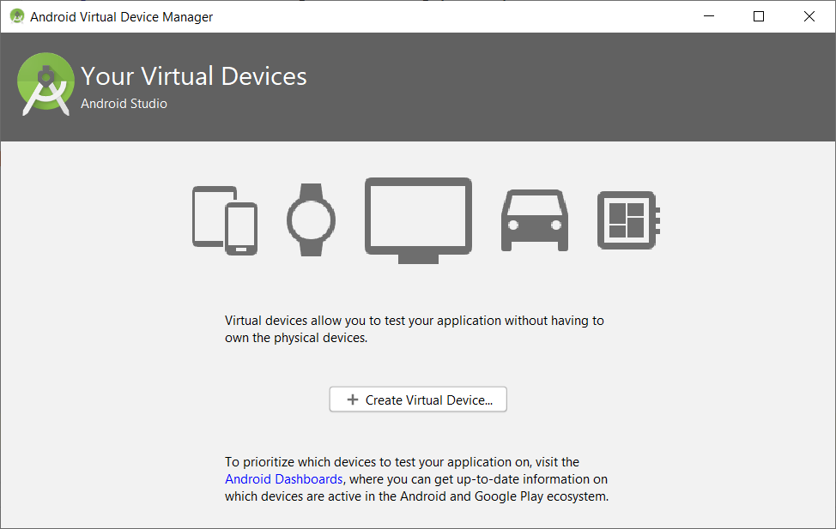

Select Create Virtual Device →Select Phone →Pixel 2 → Press Next
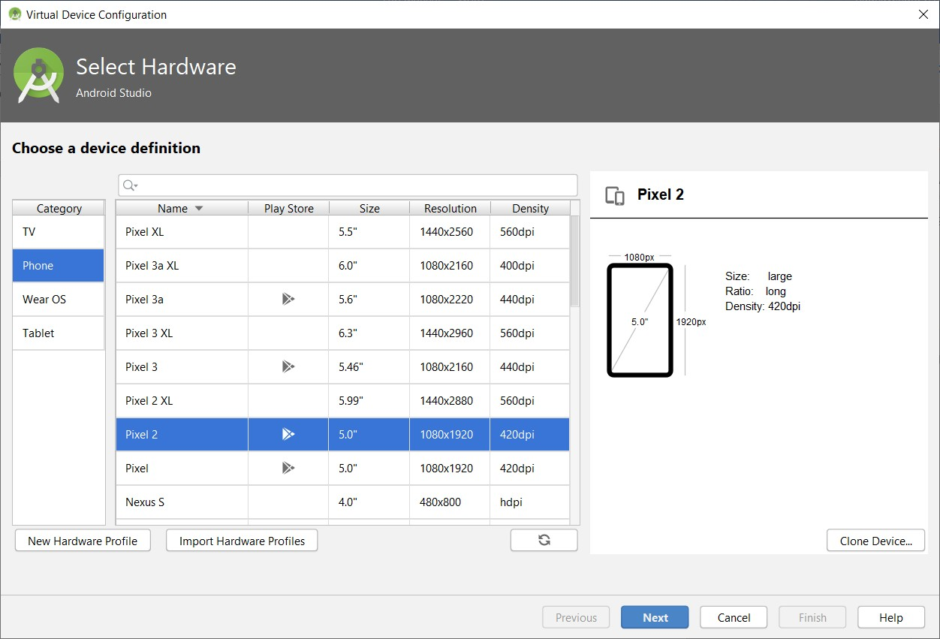
Select Android Q, if not already downloaded press download, After download completes Select Q and Press Next Button.

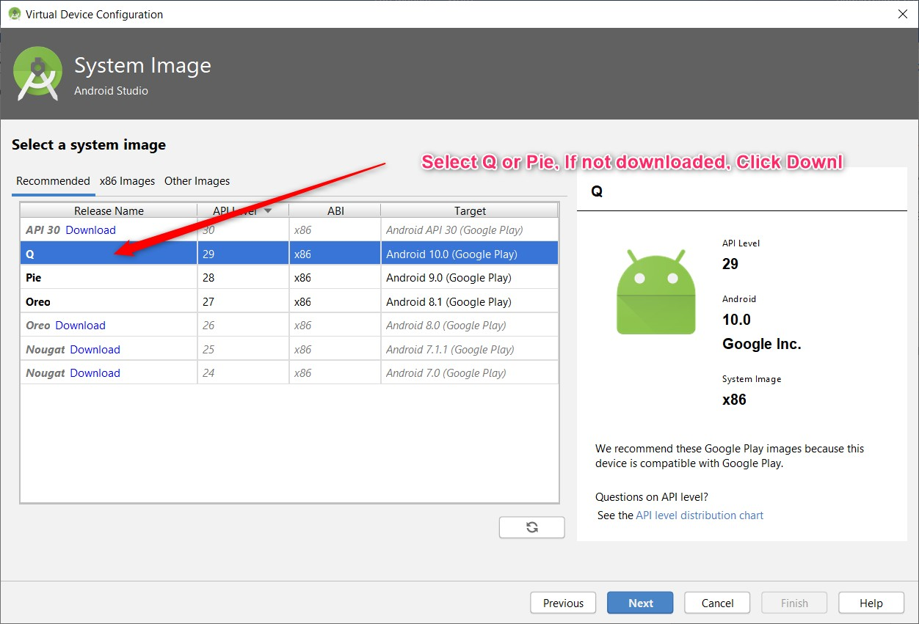

Enter AVD Name and Press Finish.
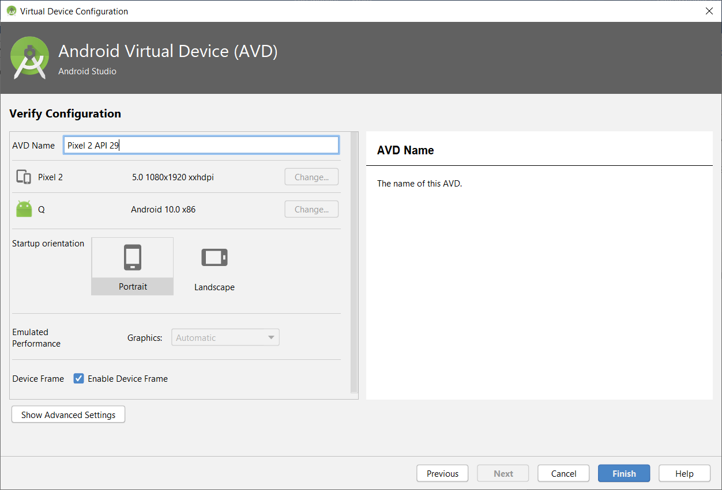
Press Play Button to Start Emulator

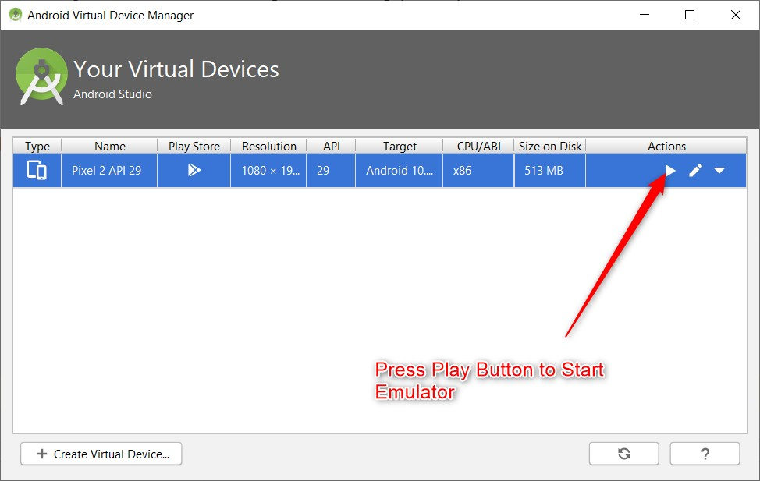

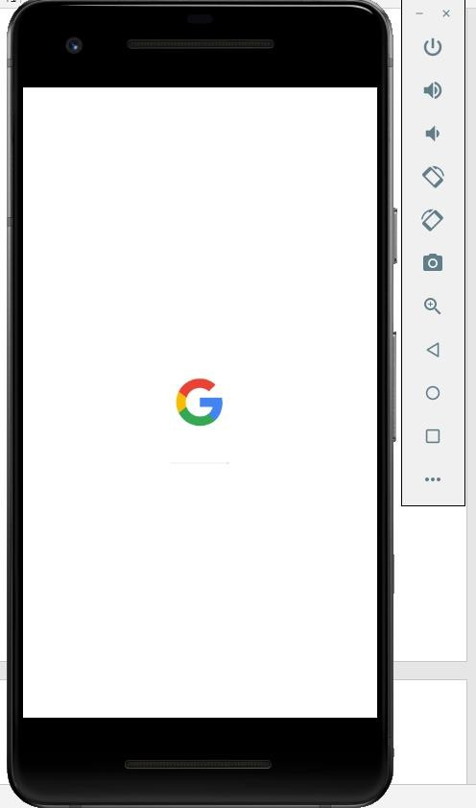

Creating a New Project in Android

While creating a New Project for First Time, make sure Android Studio is connected to internet, It downloads the required packages from internet.
Go to File →New →New Project
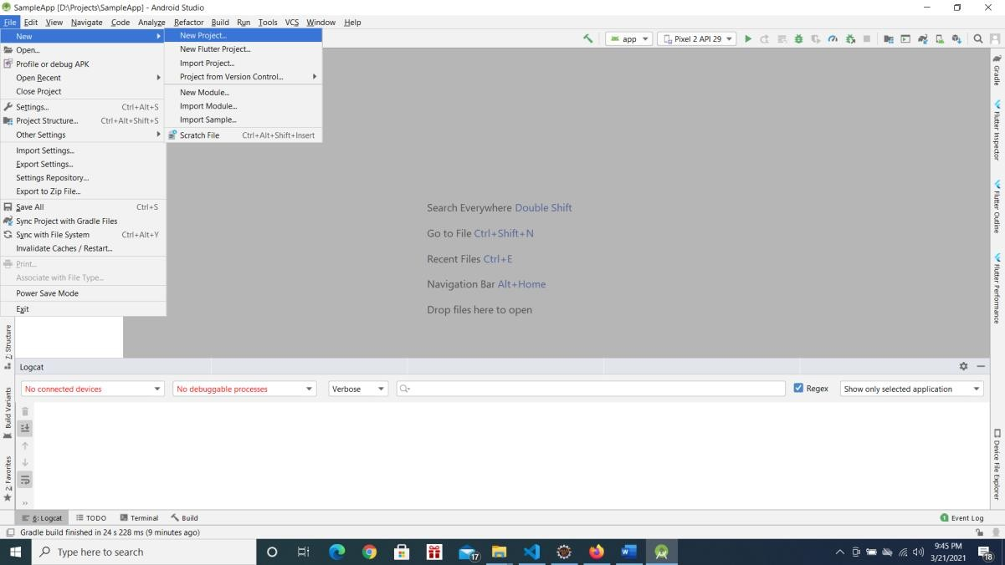

Choose Phone and Tablet → Empty Activity → Press Next

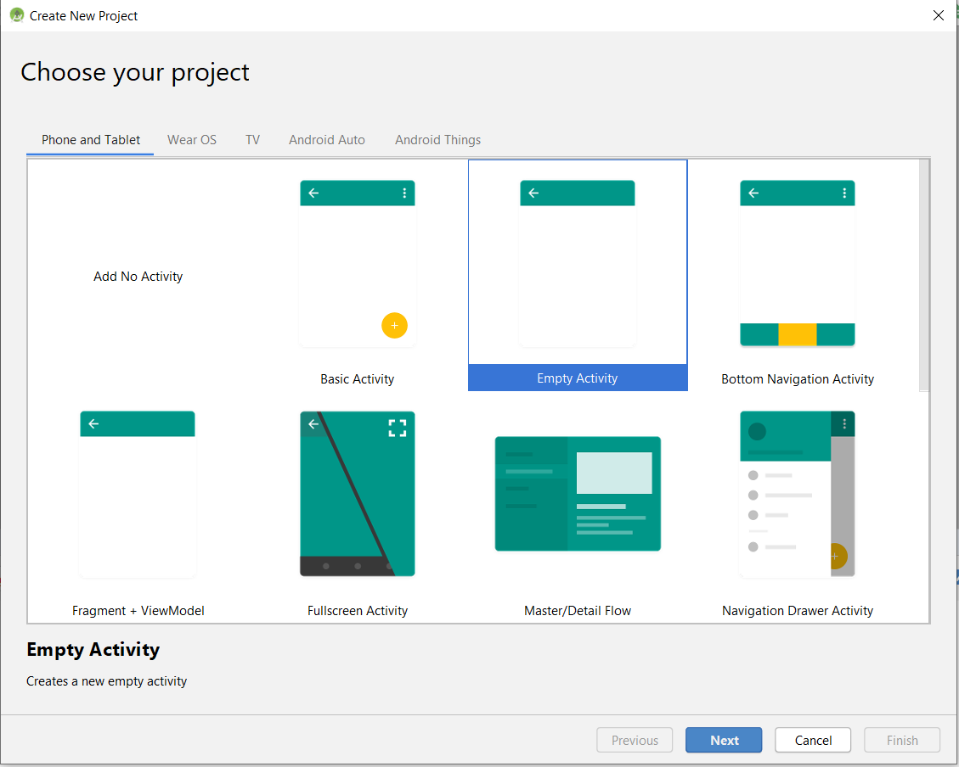

In Configure your Project Screen, Enter below details and Press Finish Button.
Enter Name of the Application → This will be application name this will be visible with Home Screen Icon.

Package Name → Enter package name atleast two identifier (Eg: com.example). Best Practice is 3 or more identifier (Eg: com.example.firstapp).

Save Location →Location where to save the Project Language → Choose Java
Minimum API Level → Android 5.0

Select Checkbox Use androidx.artifacts folder as below screenshot.
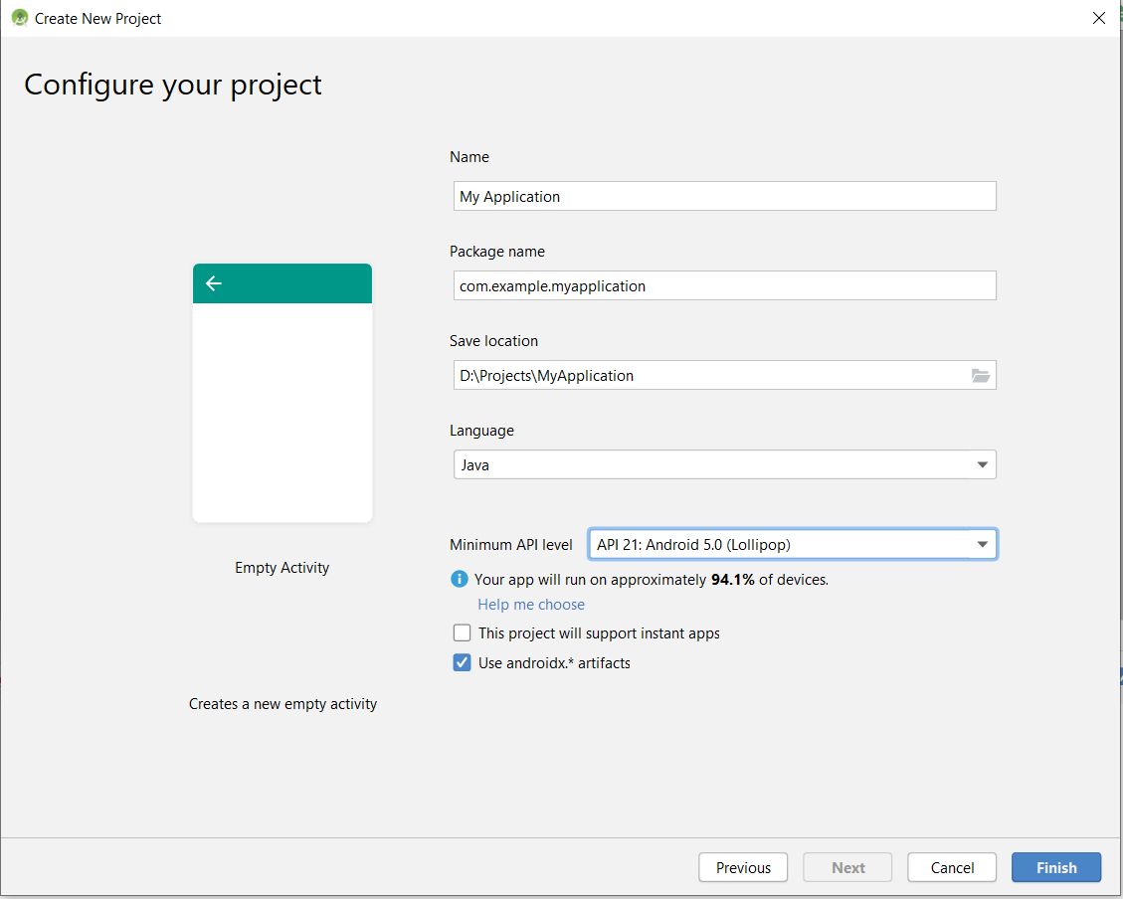

Android Project Structure:
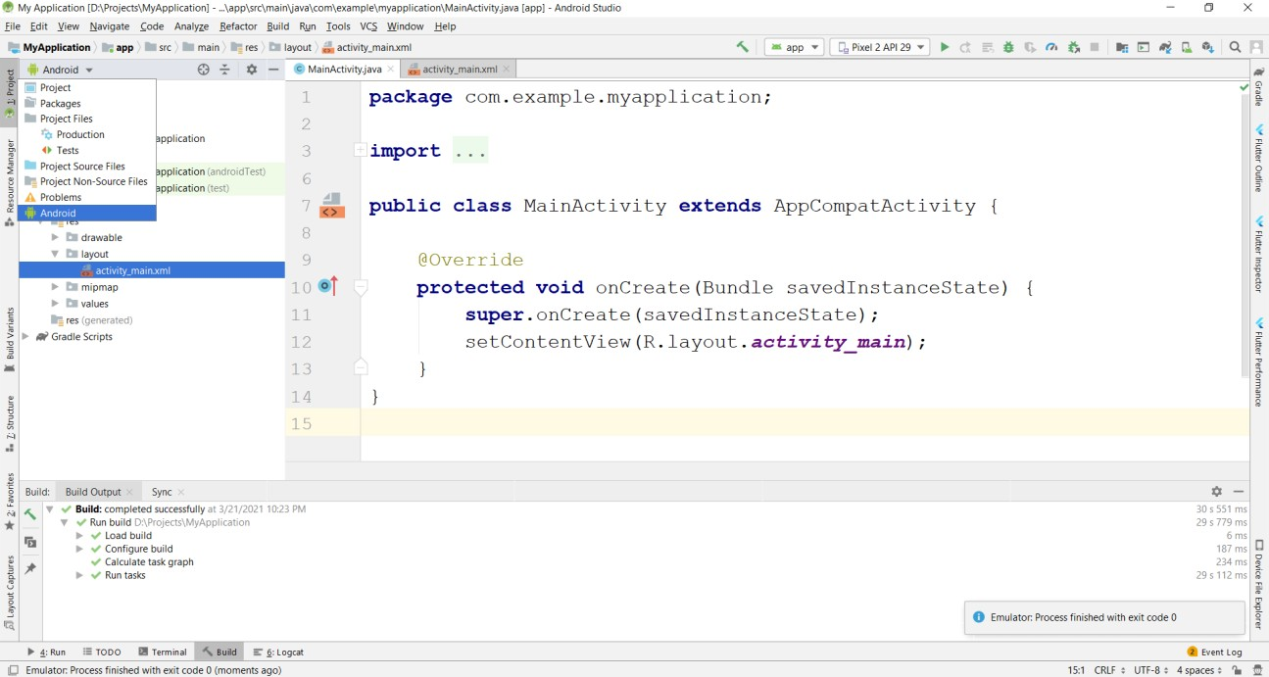

Select Project Explorer and Select Android from Project View
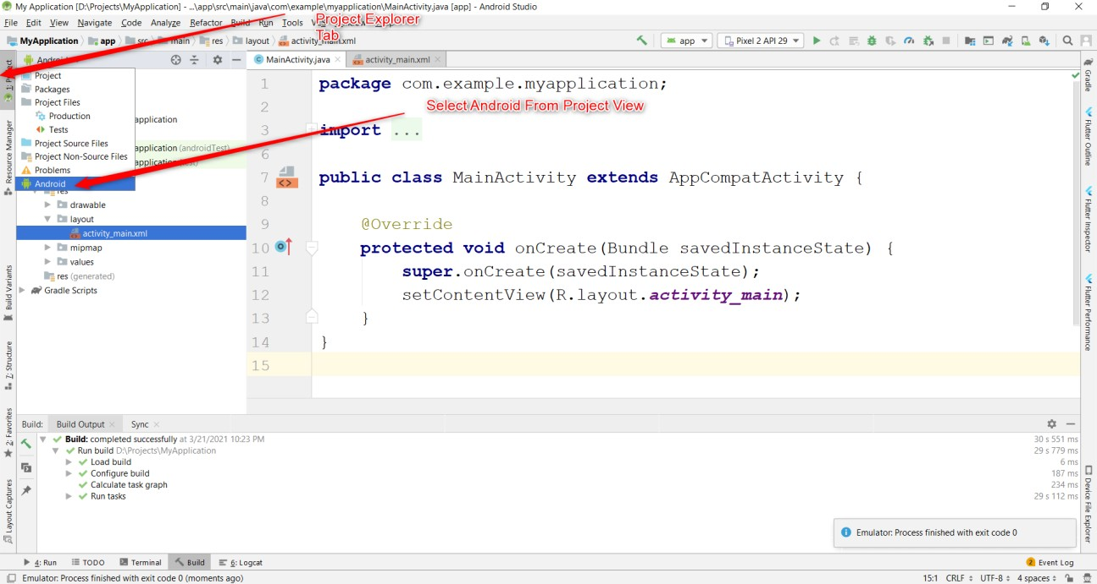

Basic View:
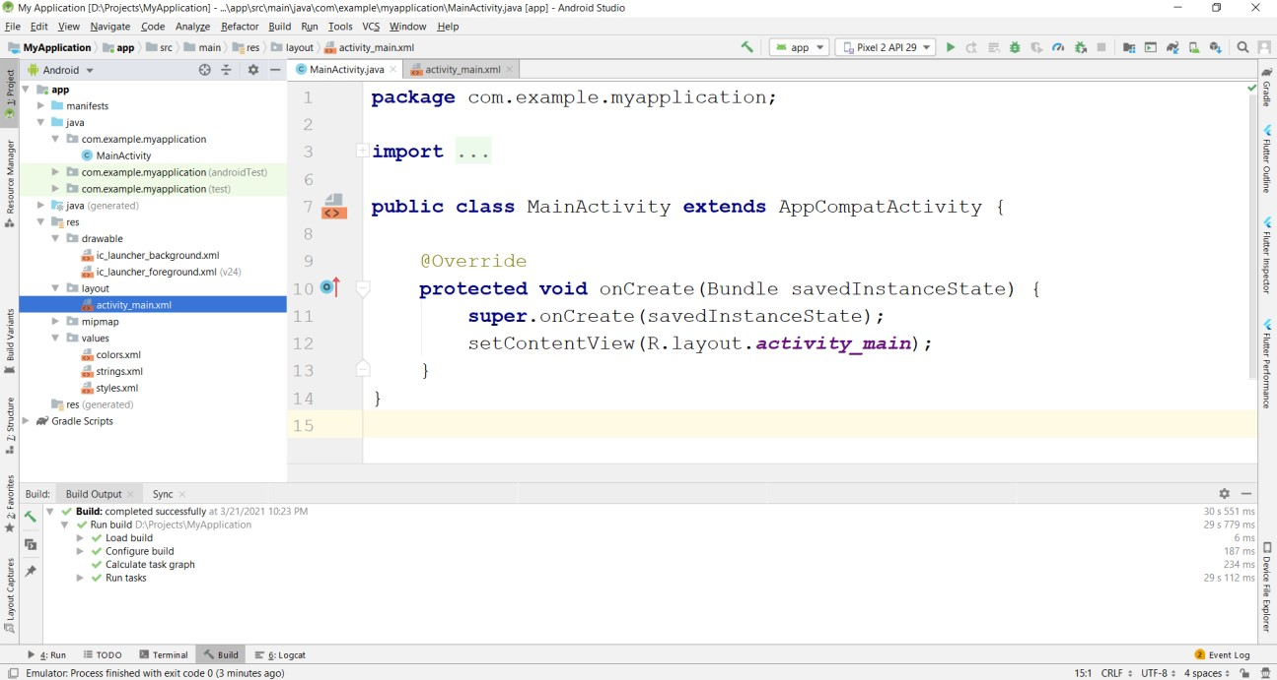
- Importing an Existing Project in Android Studio
- Creating an Activity in Android
Right Click on Package → New → Activity→ Empty Activity
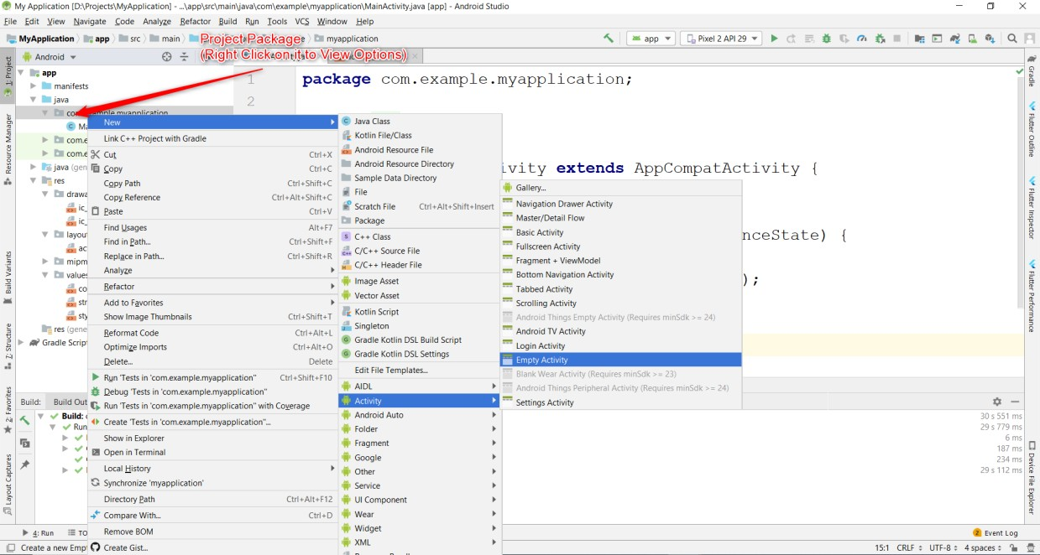

Enter Activity Name and Press Finish

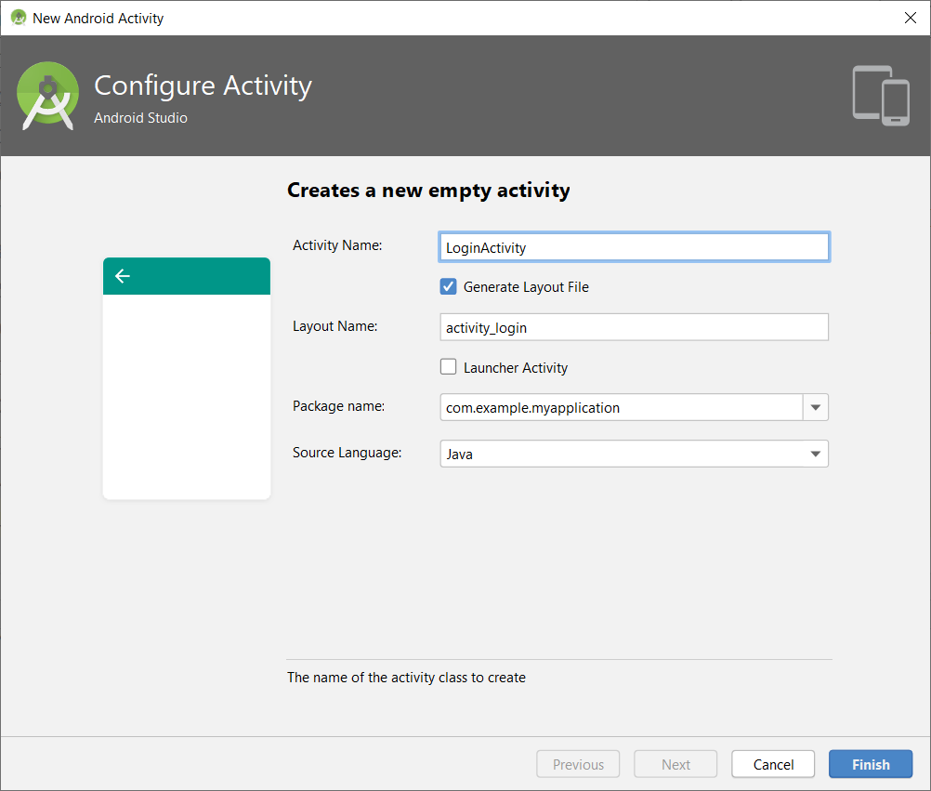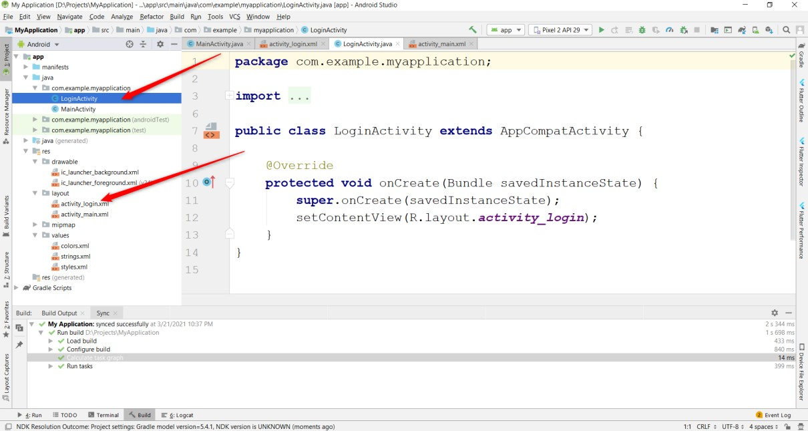

Creating a Layout in Android

Right Click on Layout Folder → New → XML→Layout XML File
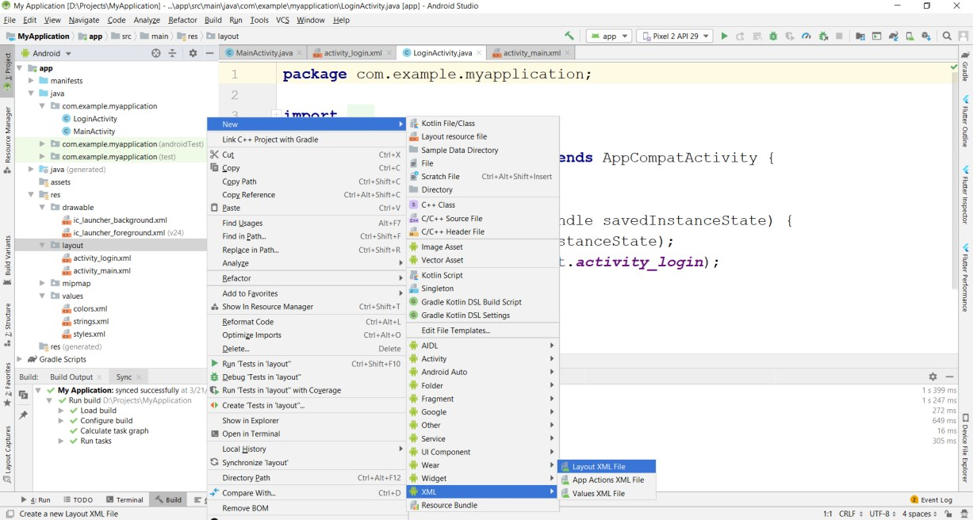

Enter xml file name and press Finish
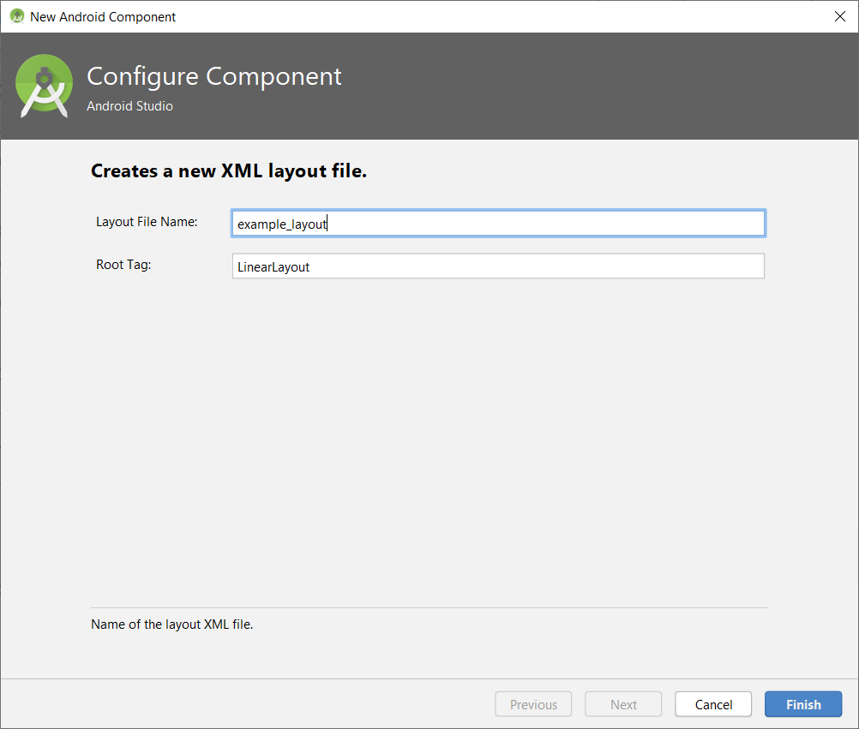

Creating Assets Folder in Android

Right Click on app folder → New → Folder → Assets Folder → Press Finish Button
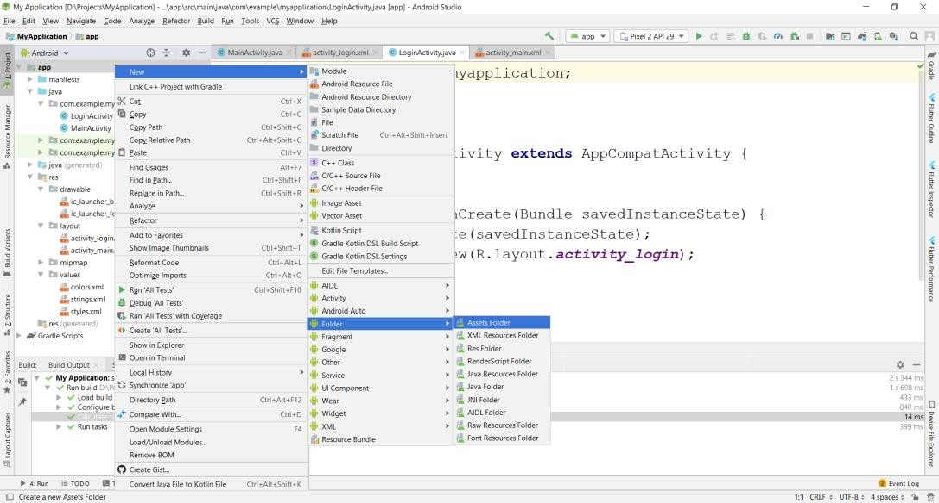

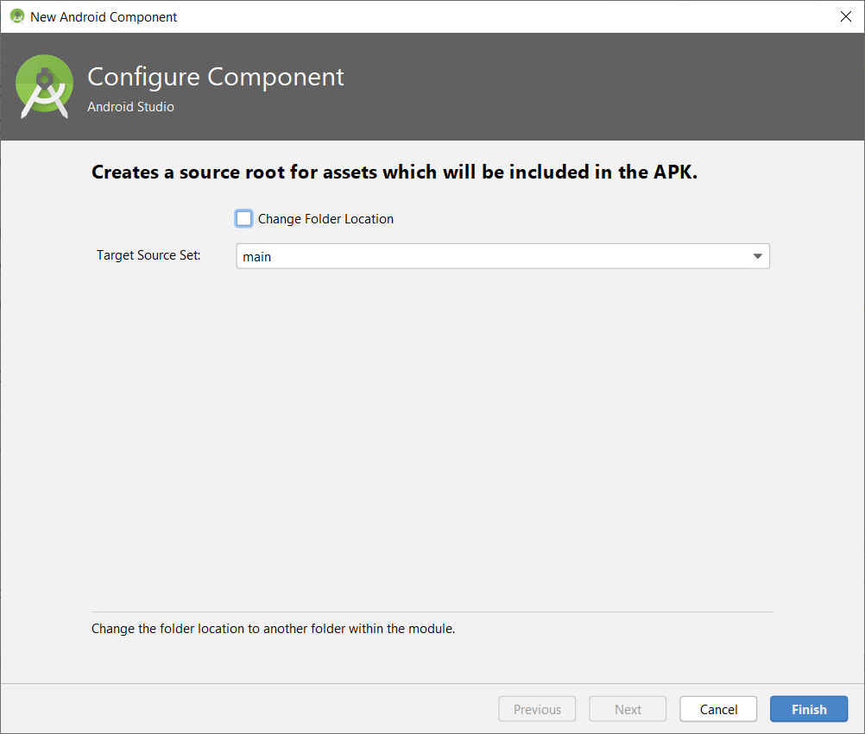

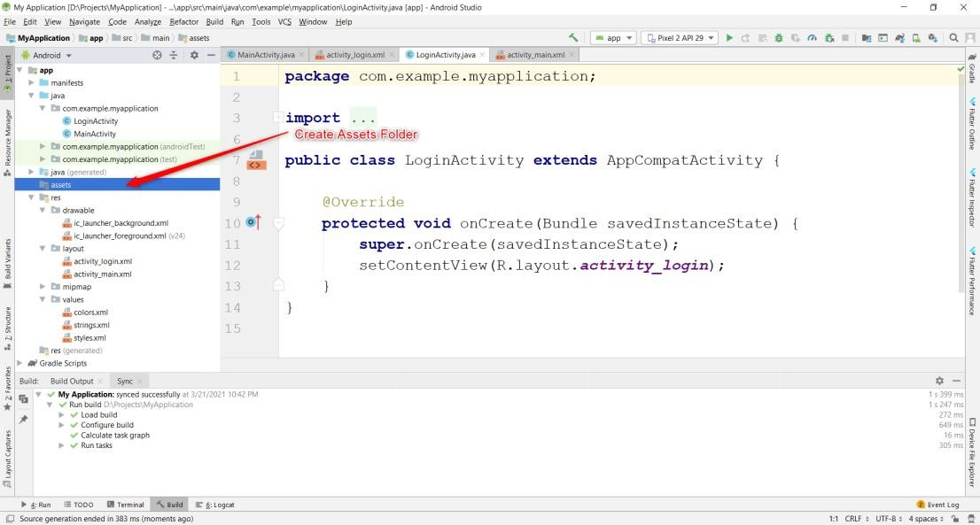

Creating File in assets Folder:

Right Click on assets folder → New → File
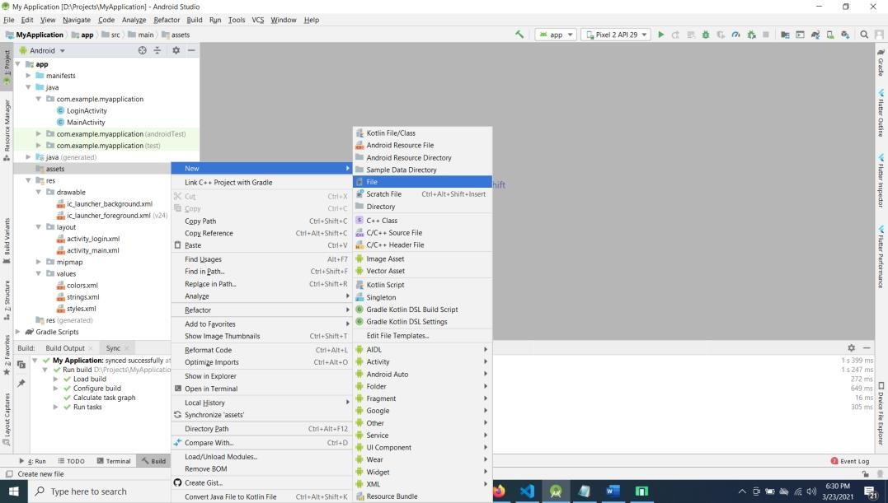
Enter filename with extension (Eg: abc.xml)

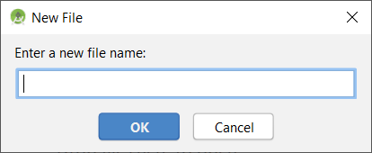

Programs PART A

Program 1
Create an application to design a Visiting Card. The Visiting card should have a company logo at the top right corner. The company name should be displayed in Capital letters, aligned to the center. Information like the name of the employee, job title, phone number, address, email, fax and the website address is to be displayed. Insert a horizontal line between the job title and the phone number.
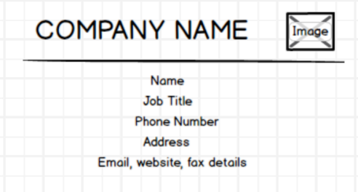

    - Create a New Android Project with Empty Activity.
    - Open activity_main.xml file from res→ layout folder, check/add Linear Layout or Relative Layout as the root view.
    - Create layout using nested Relative Layout and TextView.
    - Use View background property to draw the line
    - Add Image to drawable folder in res and reference the image in the layout using @drawable/<image_name>
    - Use android:layout_gravity/android:gravity properties to center the components.

Design



activity_main.xml
android:text="GLOBAL TECHNOLOGY LTD" android:textColor="#E61717" android:textSize="20sp" />

<ImageView android:id="@+id/imageView4" android:layout_width="48dp" android:layout_height="match_parent" android:layout_alignParentBottom="true" android:layout_marginLeft="11dp" android:layout_marginBottom="0dp" android:layout_toRightOf="@id/textView" app:srcCompat="@drawable/gat_logo" />

</RelativeLayout>

<View android:layout_width="match_parent" android:layout_height="2dp" android:background="#000000"
/>

<TextView android:layout_width="match_parent" android:layout_height="wrap_content" android:text="Amith" android:textSize="16dp"

android:layout_marginBottom="10dp" android:layout_marginTop="10dp" android:textColor="#000000" android:gravity="center"
/>

<TextView android:layout_width="match_parent" android:layout_height="wrap_content" android:text="software developer" android:textSize="16dp" android:layout_marginBottom="10dp" android:layout_marginTop="10dp" android:textColor="#000000" android:gravity="center"
/>
<View android:layout_width="match_parent" android:layout_height="2dp" android:background="#000000"
/>
<TextView android:layout_width="match_parent" android:layout_height="wrap_content" android:text="+91-91082-75635" android:textSize="16dp" android:layout_marginBottom="10dp" android:layout_marginTop="10dp" android:textColor="#000000" android:gravity="center"
/>

<TextView android:layout_width="match_parent" android:layout_height="wrap_content" android:text="Bangalore" android:textSize="16dp" android:layout_marginBottom="10dp" android:layout_marginTop="10dp" android:textColor="#000000" android:gravity="center"
/>

<TextView android:layout_width="match_parent" android:layout_height="wrap_content"
android:text="Email:info@gat.ac.in, Website:https://gat.ac.in/, Fax:+91-80- 28603158"
android:textSize="16dp" android:layout_marginBottom="10dp" android:layout_marginTop="10dp" android:textColor="#000000" android:gravity="center"
/>

</LinearLayout>

android:layout_marginBottom="10dp" android:layout_marginTop="10dp" android:textColor="#000000" android:gravity="center"
/>

<TextView android:layout_width="match_parent" android:layout_height="wrap_content" android:text="software developer" android:textSize="16dp" android:layout_marginBottom="10dp" android:layout_marginTop="10dp" android:textColor="#000000" android:gravity="center"
/>
<View android:layout_width="match_parent" android:layout_height="2dp" android:background="#000000"
/>
<TextView android:layout_width="match_parent" android:layout_height="wrap_content" android:text="+91-91082-75635" android:textSize="16dp" android:layout_marginBottom="10dp" android:layout_marginTop="10dp" android:textColor="#000000" android:gravity="center"
/>

<TextView android:layout_width="match_parent" android:layout_height="wrap_content" android:text="Bangalore" android:textSize="16dp" android:layout_marginBottom="10dp" android:layout_marginTop="10dp" android:textColor="#000000" android:gravity="center"
/>

<TextView android:layout_width="match_parent" android:layout_height="wrap_content"
android:text="Email:info@gat.ac.in, Website:https://gat.ac.in/, Fax:+91-80- 28603158"
android:textSize="16dp" android:layout_marginBottom="10dp" android:layout_marginTop="10dp" android:textColor="#000000" android:gravity="center"
/>

</LinearLayout>

Sample Output

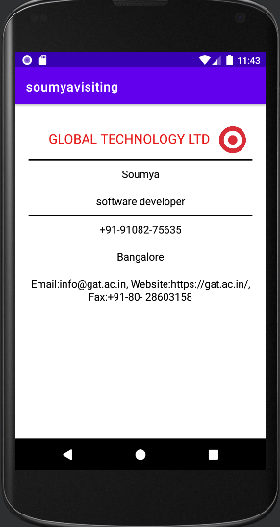

Program 2
Develop an Android application using controls like Button, TextView, EditText for designing a Calculator having basic functionality like Addition, Subtraction, Multiplication, and Division.

- Create a New Android Project with Empty Activity.
- Open activity_main.xml file from res→ layout folder, check/add Constraint Layout as the root view.
- Create Layout using Drag and Drop framework.
- Open MainActivty.java file, Override onCreate() method and bring activity_main.xml file on screen using setContentView() and bring the view references using findViewById() method.
- Add Listeners to Button Click Event:
- Create a class which implements OnClickListener interface.
- Override onClick() method of OnClickListener Interface.
- Register the button for click event by calling setOnClickListener() method of View class and pass the object of the class that implemented OnClickListener Interface.
- Create a logic to Add/Subtract/Multiply/Divide to perform arithmetic operation on 2 operands (Eg: 10+20), If more than 2 operands or wrong input, display invalid input messages.

Design
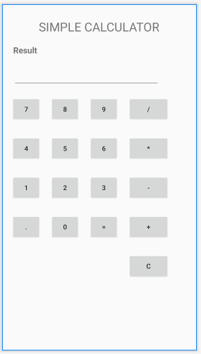

activity_main.xml

<?xml version="1.0" encoding="utf-8"?>
<androidx.constraintlayout.widget.ConstraintLayoutxmlns:android="http://schemas.andr oid.com/apk/res/android"
xmlns:app="http://schemas.android.com/apk/res-auto" xmlns:tools="http://schemas.android.com/tools" android:layout_width="match_parent" android:layout_height="match_parent" tools:context=".MainActivity">

<Button android:id="@+id/button_clear" android:layout_width="87dp" android:layout_height="53dp" android:layout_marginTop="30dp" android:text="C"
app:layout_constraintStart_toStartOf="@+id/button_add" app:layout_constraintTop_toBottomOf="@+id/button_add" />

<Button android:id="@+id/button_sub" android:layout_width="87dp" android:layout_height="53dp" android:layout_marginStart="20dp" android:layout_marginTop="30dp" android:text="-"
app:layout_constraintStart_toEndOf="@+id/button_three" app:layout_constraintTop_toBottomOf="@+id/button_mul" />

<Button android:id="@+id/button_add" android:layout_width="87dp" android:layout_height="53dp" android:layout_marginStart="20dp" android:layout_marginTop="30dp" android:text="+"
app:layout_constraintStart_toEndOf="@+id/button_equal" app:layout_constraintTop_toBottomOf="@+id/button_sub" />

<Button android:id="@+id/button_mul" android:layout_width="87dp" android:layout_height="53dp" android:layout_marginStart="20dp" android:layout_marginTop="30dp" android:text="*"
app:layout_constraintStart_toEndOf="@+id/button_six" app:layout_constraintTop_toBottomOf="@+id/button_div" />

<Button android:id="@+id/button_equal" android:layout_width="62dp" android:layout_height="53dp" android:layout_marginStart="20dp" android:layout_marginTop="30dp" android:text="="
app:layout_constraintStart_toEndOf="@+id/button_zero" app:layout_constraintTop_toBottomOf="@+id/button_three" />

<Button android:id="@+id/button_zero" android:layout_width="62dp" android:layout_height="53dp" android:layout_marginStart="20dp" android:layout_marginTop="30dp" android:text="0"
app:layout_constraintStart_toEndOf="@+id/button_dot" app:layout_constraintTop_toBottomOf="@+id/button_two" />

<Button android:id="@+id/button_dot" android:layout_width="62dp" android:layout_height="53dp" android:layout_marginStart="20dp" android:layout_marginTop="30dp" android:text="."
app:layout_constraintStart_toStartOf="parent" app:layout_constraintTop_toBottomOf="@+id/button_one" />

<Button android:id="@+id/button_three" android:layout_width="62dp" android:layout_height="53dp" android:layout_marginStart="20dp" android:layout_marginTop="30dp" android:text="3"
app:layout_constraintStart_toEndOf="@+id/button_two" app:layout_constraintTop_toBottomOf="@+id/button_six" />

<Button android:id="@+id/button_two" android:layout_width="62dp" android:layout_height="53dp" android:layout_marginStart="20dp" android:layout_marginTop="30dp" android:text="2"
app:layout_constraintStart_toEndOf="@+id/button_one" app:layout_constraintTop_toBottomOf="@+id/button_five" />

<Button android:id="@+id/button_one" android:layout_width="62dp" android:layout_height="53dp" android:layout_marginStart="20dp" android:layout_marginTop="30dp" android:text="1"
app:layout_constraintStart_toStartOf="parent" app:layout_constraintTop_toBottomOf="@+id/button_four" />

<Button android:id="@+id/button_six" android:layout_width="62dp" android:layout_height="53dp" android:layout_marginStart="20dp" android:layout_marginTop="30dp" android:text="6"
app:layout_constraintStart_toEndOf="@+id/button_five" app:layout_constraintTop_toBottomOf="@+id/button_nine" />

<Button android:id="@+id/button_seven" android:layout_width="62dp" android:layout_height="53dp" android:layout_marginStart="20dp" android:layout_marginTop="20dp" android:text="7"
app:layout_constraintStart_toStartOf="parent" app:layout_constraintTop_toBottomOf="@+id/txt_result" />

<Button android:id="@+id/button_eight" android:layout_width="62dp" android:layout_height="53dp" android:layout_marginStart="20dp" android:layout_marginTop="20dp" android:text="8"
app:layout_constraintStart_toEndOf="@+id/button_seven" app:layout_constraintTop_toBottomOf="@+id/txt_result" />

<Button android:id="@+id/button_nine" android:layout_width="62dp" android:layout_height="53dp" android:layout_marginStart="20dp" android:layout_marginTop="20dp" android:text="9"
app:layout_constraintStart_toEndOf="@+id/button_eight" app:layout_constraintTop_toBottomOf="@+id/txt_result" />

<Button android:id="@+id/button_four" android:layout_width="62dp" android:layout_height="53dp" android:layout_marginStart="20dp" android:layout_marginTop="30dp" android:text="4"
app:layout_constraintStart_toStartOf="parent" app:layout_constraintTop_toBottomOf="@+id/button_seven" />

<TextView android:id="@+id/textView" android:layout_width="wrap_content"
android:layout_height="wrap_content" android:layout_marginTop="30dp" android:text="SIMPLE CALCULATOR" android:textSize="26dp" app:layout_constraintEnd_toEndOf="parent" app:layout_constraintStart_toStartOf="parent" app:layout_constraintTop_toTopOf="parent" />

<TextView android:id="@+id/textView2" android:layout_width="wrap_content" android:layout_height="wrap_content" android:layout_marginStart="20dp" android:layout_marginTop="20dp" android:text="Result" android:textSize="18dp" android:textStyle="bold"
app:layout_constraintEnd_toStartOf="@+id/textView" app:layout_constraintStart_toStartOf="parent" app:layout_constraintTop_toBottomOf="@+id/textView" />

<EditText android:id="@+id/txt_result" android:layout_width="310dp" android:layout_height="46dp" android:layout_marginTop="20dp" android:ems="10" android:inputType="textPersonName"
app:layout_constraintStart_toStartOf="@+id/textView2" app:layout_constraintTop_toBottomOf="@+id/textView2" />

<Button android:id="@+id/button_div" android:layout_width="87dp" android:layout_height="53dp" android:layout_marginStart="20dp" android:layout_marginTop="20dp"

android:text="/" app:layout_constraintStart_toEndOf="@+id/button_nine" app:layout_constraintTop_toBottomOf="@+id/txt_result" />

<Button android:id="@+id/button_five" android:layout_width="62dp" android:layout_height="53dp" android:layout_marginStart="20dp" android:layout_marginTop="30dp" android:text="5"
app:layout_constraintStart_toEndOf="@+id/button_four" app:layout_constraintTop_toBottomOf="@+id/button_eight" />
</androidx.constraintlayout.widget.ConstraintLayout>

MainActivity.java

package com.example.partaprogram2;

import androidx.appcompat.app.AppCompatActivity; import android.os.Bundle;
import android.view.View; import android.widget.Button; import android.widget.EditText; import android.widget.Toast;

import java.util.regex.Pattern;

public class MainActivityextendsAppCompatActivityimplementsView.OnClickListener { Button btnOne, btnTwo, btnThree, btnFour, btnFive, btnSix;
Button btnSeven, btnEight, btnNine, btnZero; Button btnAdd,btnSub,btnMul,btnDiv;
Button btnClear,btnEqual,btnDot; EditTexttxtResult;
@Override
protected void onCreate(Bundle savedInstanceState) { super.onCreate(savedInstanceState); setContentView(R.layout.activity_main);

btnOne=(Button)findViewById(R.id.button_one); btnOne.setOnClickListener(this);

btnTwo=(Button)findViewById(R.id.button_two); btnTwo.setOnClickListener(this);

btnThree=(Button)findViewById(R.id.button_three); btnThree.setOnClickListener(this);

btnFour=(Button)findViewById(R.id.button_four); btnFour.setOnClickListener(this);

btnFive=(Button)findViewById(R.id.button_five); btnFive.setOnClickListener(this);

btnSix=(Button)findViewById(R.id.button_six); btnSix.setOnClickListener(this);

btnSeven=(Button)findViewById(R.id.button_seven); btnSeven.setOnClickListener(this);

btnEight=(Button)findViewById(R.id.button_eight); btnEight.setOnClickListener(this);

btnNine=(Button)findViewById(R.id.button_nine); btnNine.setOnClickListener(this);

btnZero=(Button)findViewById(R.id.button_zero); btnZero.setOnClickListener(this);

btnAdd=(Button)findViewById(R.id.button_add); btnAdd.setOnClickListener(this);

btnSub=(Button)findViewById(R.id.button_sub); btnSub.setOnClickListener(this);

btnMul=(Button)findViewById(R.id.button_mul); btnMul.setOnClickListener(this);

btnDiv=(Button)findViewById(R.id.button_div); btnDiv.setOnClickListener(this);

btnClear=(Button)findViewById(R.id.button_clear); btnClear.setOnClickListener(this);

btnEqual=(Button)findViewById(R.id.button_equal); btnEqual.setOnClickListener(this);

btnDot=(Button)findViewById(R.id.button_dot); btnDot.setOnClickListener(this);

txtResult=(EditText)findViewById(R.id.txt_result); txtResult.setText("");
}

public void onClick(View v)
{
if(v.equals(btnOne)) txtResult.append("1"); if(v.equals(btnTwo)) txtResult.append("2"); if(v.equals(btnThree)) txtResult.append("3"); if(v.equals(btnFour)) txtResult.append("4"); if(v.equals(btnFive)) txtResult.append("5"); if(v.equals(btnSix)) txtResult.append("6"); if(v.equals(btnSeven)) txtResult.append("7"); if(v.equals(btnEight)) txtResult.append("8"); if(v.equals(btnNine)) txtResult.append("9"); if(v.equals(btnZero)) txtResult.append("0"); if(v.equals(btnDot)) txtResult.append("."); if(v.equals(btnClear)) txtResult.setText("");

if(v.equals(btnEqual))
{
try {

String data = txtResult.getText().toString(); if (data.contains("/")) {
String[] operands = data.split("/"); if(operands.length==2) {
double operand1 = Double.parseDouble(operands[0]); double operand2 = Double.parseDouble(operands[1]); double result = operand1 / operand2; txtResult.setText(String.valueOf(result));
}
else
{
Toast.makeText(getBaseContext(),"Invalid Input", Toast.LENGTH_LONG).show();
}

}
else if (data.contains("*")) {
String[] operands = data.split(Pattern.quote("*")); if(operands.length==2) {
double operand1 = Double.parseDouble(operands[0]); double operand2 = Double.parseDouble(operands[1]);

double result = operand1 * operand2; txtResult.setText(String.valueOf(result));
}
else
{
Toast.makeText(getBaseContext(),"Invalid Input", Toast.LENGTH_LONG).show();
}

}
else if (data.contains("+")) {
String[] operands = data.split(Pattern.quote("+")); if(operands.length==2) {
double operand1 = Double.parseDouble(operands[0]); double operand2 = Double.parseDouble(operands[1]); double result = operand1 + operand2; txtResult.setText(String.valueOf(result));
}
else
{
Toast.makeText(getBaseContext(),"Invalid Input", Toast.LENGTH_LONG).show();
}
}
else if (data.contains("-")) { String[] operands = data.split("-"); if(operands.length==2) {
double operand1 = Double.parseDouble(operands[0]); double operand2 = Double.parseDouble(operands[1]); double result = operand1 - operand2; txtResult.setText(String.valueOf(result));
}
else
{
Toast.makeText(getBaseContext(),"Invalid Input", Toast.LENGTH_LONG).show();
}
}
}

catch(Exception e) { Toast.makeText(getBaseContext(),"Invalid Input", Toast.LENGTH_LONG).show();
}
}

if(v.equals(btnAdd)) txtResult.append("+"); if(v.equals(btnSub)) txtResult.append("-"); if(v.equals(btnMul)) txtResult.append("*"); if(v.equals(btnDiv)) txtResult.append("/");
}
}

Sample Output
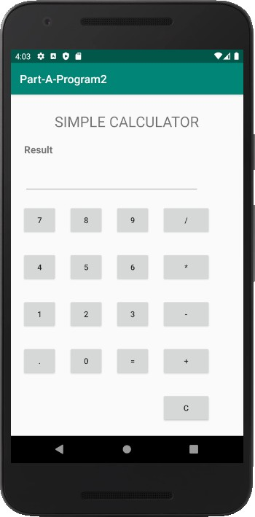

Program 3
Create a SIGN Up activity with Username and Password. Validation of password should happen based on the following rules:
- Password should contain uppercase and lowercase letters.
- Password should contain letters and numbers.
- Password should contain special characters.
- Minimum length of the password (the default value is 8).
On successful SIGN UP proceed to the next Login activity. Here the user should SIGN IN using the Username and Password created during signup activity. If the Username and Password are matched then navigate to the next activity which displays a message saying “Successful Login” or else display a toast message saying “Login Failed”. The user is given only two attempts and after that display a toast message saying “Failed Login Attempts” and disable the SIGN IN button. Use Bundle to transfer information from one activity to another.

- Create a New Android Project with Empty Activity.
- Open activity_main.xml file from res→ layout folder, check/add Constraint Layout as the root view.
- Create Signup Layout using Drag and Drop framework design the layout.
- Create One more Empty Activity LoginActivity using Android Studio Create Activity Flow (Refer Android Studio Tutorial)
- Open activity_login.xml file from res→layout folder, check/add Constraint Layout as the root view.
- Create Login Layout using Drag and Drop framework.
- Add Listeners to Button Click Event:
  - Create a class which implements OnClickListener interface.
  - Override onClick() method of OnClickListener Interface.
  - Register the button for click event by calling setOnClickListener() method of View class and pass the object of the class that implemented OnClickListener Interface.
8. Use Regular Expression"^(?=.*[A-Z])(?=.*[a-z])(?=.*\\d)(?=.*[@$!])[A-Za- z\\d@$!]{8,}$” to validate the password.

Design
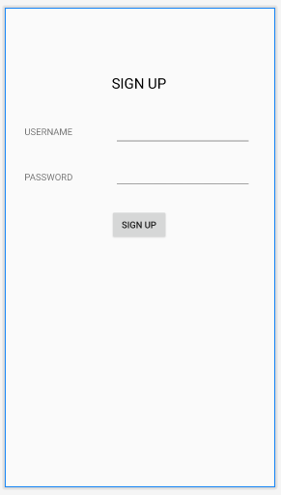
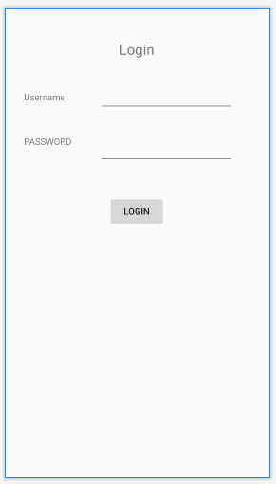
Activity_main.xml

<?xml version="1.0" encoding="utf-8"?>
<androidx.constraintlayout.widget.ConstraintLayoutxmlns:android="http://schemas.andr oid.com/apk/res/android"
xmlns:app="http://schemas.android.com/apk/res-auto" xmlns:tools="http://schemas.android.com/tools" android:layout_width="match_parent" android:layout_height="match_parent" tools:context=".MainActivity">

<TextView android:id="@+id/textView2" android:layout_width="wrap_content" android:layout_height="wrap_content" android:layout_marginTop="100dp" android:text="SIGN UP"
android:textColor="@android:color/background_dark" android:textSize="22dp" app:layout_constraintEnd_toEndOf="parent" app:layout_constraintStart_toStartOf="parent" app:layout_constraintTop_toTopOf="parent" />

<TextView android:id="@+id/textView3" android:layout_width="wrap_content" android:layout_height="wrap_content"

android:layout_marginStart="30dp" android:layout_marginTop="50dp" android:text="USERNAME" app:layout_constraintStart_toStartOf="parent"
app:layout_constraintTop_toBottomOf="@+id/textView2" />

<TextView android:id="@+id/textView4" android:layout_width="82dp" android:layout_height="34dp" android:layout_marginTop="50dp" android:text="PASSWORD"
app:layout_constraintStart_toStartOf="@+id/textView3" app:layout_constraintTop_toBottomOf="@+id/textView3" />

<EditText android:id="@+id/txt_username" android:layout_width="wrap_content" android:layout_height="wrap_content" android:layout_marginStart="40dp" android:layout_marginEnd="10dp" android:ems="10" android:inputType="textPersonName"
app:layout_constraintBottom_toBottomOf="@+id/textView3" app:layout_constraintEnd_toEndOf="parent" app:layout_constraintStart_toEndOf="@+id/textView3" app:layout_constraintTop_toTopOf="@+id/textView3" />

<EditText android:id="@+id/txt_password" android:layout_width="0dp" android:layout_height="40dp" android:layout_marginTop="26dp" android:ems="10" android:inputType="textPassword"
app:layout_constraintEnd_toEndOf="@+id/txt_username" app:layout_constraintStart_toStartOf="@+id/txt_username" app:layout_constraintTop_toBottomOf="@+id/txt_username" />

<Button android:id="@+id/btn_signup" android:layout_width="wrap_content"
android:layout_height="wrap_content" android:layout_marginTop="30dp" android:text="Sign Up" app:layout_constraintEnd_toEndOf="parent" app:layout_constraintStart_toStartOf="parent"
app:layout_constraintTop_toBottomOf="@+id/txt_password" />
</androidx.constraintlayout.widget.ConstraintLayout>

Activity_login.xml

<?xml version="1.0" encoding="utf-8"?>
<androidx.constraintlayout.widget.ConstraintLayoutxmlns:android="http://schemas.andr oid.com/apk/res/android"
xmlns:app="http://schemas.android.com/apk/res-auto" xmlns:tools="http://schemas.android.com/tools" android:layout_width="match_parent" android:layout_height="match_parent" tools:context=".LoginActivity">

<TextView android:id="@+id/textView7" android:layout_width="wrap_content" android:layout_height="wrap_content" android:layout_marginTop="50dp" android:text="Login" android:textSize="22dp"
app:layout_constraintEnd_toEndOf="parent" app:layout_constraintStart_toStartOf="parent" app:layout_constraintTop_toTopOf="parent" />

<TextView android:id="@+id/textView9" android:layout_width="wrap_content" android:layout_height="wrap_content" android:layout_marginStart="30dp" android:layout_marginTop="50dp" android:text="Username"
app:layout_constraintStart_toStartOf="parent" app:layout_constraintTop_toBottomOf="@+id/textView7" />

<EditText android:id="@+id/txt_login_username" android:layout_width="wrap_content" android:layout_height="wrap_content" android:layout_marginStart="20dp" android:layout_marginEnd="20dp" android:ems="10" android:inputType="textPersonName"
app:layout_constraintBottom_toBottomOf="@+id/textView9" app:layout_constraintEnd_toEndOf="parent" app:layout_constraintStart_toEndOf="@+id/textView9" app:layout_constraintTop_toTopOf="@+id/textView9" />

<TextView android:id="@+id/textView10" android:layout_width="wrap_content" android:layout_height="wrap_content" android:layout_marginStart="30dp" android:layout_marginTop="50dp"

android:text="PASSWORD" app:layout_constraintStart_toStartOf="parent" app:layout_constraintTop_toBottomOf="@+id/textView9" />

<EditText android:id="@+id/txt_login_password" android:layout_width="wrap_content" android:layout_height="wrap_content" android:ems="10" android:inputType="textPassword"
app:layout_constraintEnd_toEndOf="@+id/txt_login_username" app:layout_constraintStart_toStartOf="@+id/txt_login_username" app:layout_constraintTop_toTopOf="@+id/textView10" />

<Button android:id="@+id/btn_login_signin" android:layout_width="wrap_content" android:layout_height="wrap_content" android:layout_marginTop="50dp" android:text="Login" app:layout_constraintEnd_toEndOf="parent"
app:layout_constraintStart_toStartOf="parent" app:layout_constraintTop_toBottomOf="@+id/txt_login_password" />
</androidx.constraintlayout.widget.ConstraintLayout>

MainActivity.java

package com.example.parta.program3;
import androidx.appcompat.app.AppCompatActivity; import android.content.Intent;
import android.os.Bundle;
import android.view.View; import android.widget.Button; import android.widget.EditText; import android.widget.Toast;

import java.util.regex.Matcher; import java.util.regex.Pattern;
public class MainActivityextends AppCompatActivityimplements View.OnClickListener { EditTexttxtUsername;
EditTexttxtPassword;

Button btnSignup;

String regularExpression="^(?=.*[A-Z])(?=.*[a-z])(?=.*\\d)(?=.*[@$!])[A-Za- z\\d@$!]{8,}$";

@Override
protected void onCreate(Bundle savedInstanceState) { super.onCreate(savedInstanceState); setContentView(R.layout.activity_main); txtUsername=(EditText)findViewById(R.id.txt_username); txtPassword=(EditText)findViewById(R.id.txt_password);

btnSignup=(Button)findViewById(R.id.btn_signup); btnSignup.setOnClickListener(this);

}

public void onClick(View v)
{
String username=txtUsername.getText().toString(); String password=txtPassword.getText().toString();

if(validatePassword(password)) { Bundle bundle = new Bundle(); bundle.putString("user", username);
bundle.putString("Lab@2018", password);

Intent it = new Intent(this, LoginActivity.class); it.putExtra("data", bundle);

else
{
startActivity(it);
}

Toast.makeText(getBaseContext(), "Invalid Password", Toast.LENGTH_LONG).show();
}
}

public booleanvalidatePassword(String password)
{
Pattern pattern= Pattern.compile(regularExpression); Matcher matcher=pattern.matcher(password);
return matcher.matches();

}
}

LoginActivity.java

package com.example.parta.program3;

import androidx.appcompat.app.AppCompatActivity; import android.os.Bundle;
import android.view.View; import android.widget.Button; import android.widget.EditText; import android.widget.Toast;
public class LoginActivityextends AppCompatActivityimplements View.OnClickListener { EditTexttxtLoginUsername;
EditTexttxtLoginPassword;
Button btnLogin; String user,pass;
int count=0;

@Override
protected void onCreate(Bundle savedInstanceState) { super.onCreate(savedInstanceState); setContentView(R.layout.activity_login);

txtLoginUsername=(EditText) findViewById(R.id.txt_login_username); txtLoginPassword=(EditText) findViewById(R.id.txt_login_password);

btnLogin=(Button)findViewById(R.id.btn_login_signin); btnLogin.setOnClickListener(this);

Bundle bundle=getIntent().getBundleExtra("data"); user=bundle.getString("user"); pass=bundle.getString("Lab@2018");

}

public void onClick(View v)
{
String user1=txtLoginUsername.getText().toString(); String pass1=txtLoginPassword.getText().toString();

if(user.equals(user1)&&pass.equals(pass1))
{
Toast.makeText(this,"Login Successful"
,Toast.LENGTH_LONG).show();
}
else

{
count++; if(count==3)
{
btnLogin.setEnabled(false); Toast.makeText(this, "Failed Login Attempts"
,Toast.LENGTH_LONG).show();
}
else
{
Toast.makeText(this,"Login Failed "+count
,Toast.LENGTH_LONG).show();
}
}

}
}

Sample Output

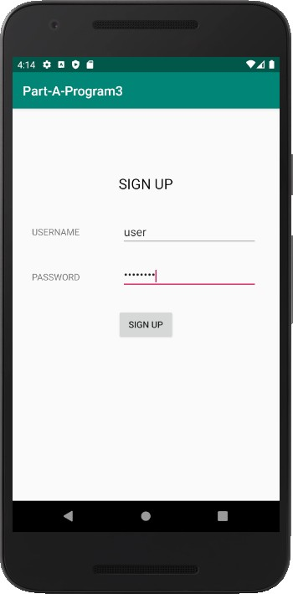
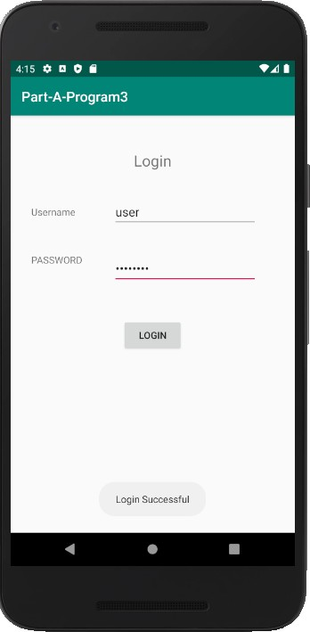

Program 4
Develop an application to set an image as wallpaper. On click of a button, the wallpaper image should start to change randomly every 30 seconds.
- Create a New Android Project with Empty Activity.
- Open activity_main.xml file from res→ layout folder, check/add LinearLayout as the root view.
- Create the layout
- Add 3 or More images to drawable folder (res→drawable)
- Declare uses permission android.permission.SET_WALLPAPPER in the AndroidManifest.xml file
- Schedule Timer task to change the wallpaper on every 30 seconds interval.
- Initialize and use WallpaperManager.setBitmap() method to change the wallpaper.

activity_main.xml

<?xml version="1.0" encoding="utf-8"?>
<LinearLayoutxmlns:android="http://schemas.android.com/apk/res/android" xmlns:app="http://schemas.android.com/apk/res-auto" xmlns:tools="http://schemas.android.com/tools" android:layout_width="match_parent" android:layout_height="match_parent"
android:orientation="vertical" android:gravity="center" tools:context=".MainActivity">

<Button android:layout_width="match_parent" android:layout_height="wrap_content"
android:text="Click here to Change Wallpaper" android:id="@+id/btn_start_change_wallpaper"/>

</LinearLayout>

MainActivity.java

package com.example.program4;
import androidx.appcompat.app.AppCompatActivity; import android.app.WallpaperManager;
import android.graphics.BitmapFactory;
import android.os.Bundle; import android.view.View; import android.widget.Button;

import java.util.Timer; import java.util.TimerTask;
public class MainActivityextends AppCompatActivityimplements View.OnClickListener{ Button btnChangeWallpaper;
booleanrunning;
int[] imagesArray=new int[]{

R.drawable.img1, R.drawable.img2, R.drawable.img3, R.drawable.img4, R.drawable.img5, R.drawable.img6, R.drawable.img7, R.drawable.img8, R.drawable.img9, R.drawable.img10, R.drawable.img11, R.drawable.img12
};
int i=0; @Override
protected void onCreate(Bundle savedInstanceState) {
super.onCreate(savedInstanceState); setContentView(R.layout.activity_main);

btnChangeWallpaper=(Button) findViewById(R.id.btn_start_change_wallpaper); btnChangeWallpaper.setOnClickListener(this);

}

public void onClick(View v)
{
if(!running)
{
new Timer().schedule (new MyTimer(),0,3000); running=true;
}
}

class MyTimerextends TimerTask
{
public void run()
{
try
{
WallpaperManagerwallpaperManager= WallpaperManager.getInstance(getBaseContext());

if(i==12) i=1;

if(i==11) i=2;

if(i==10) i=3;

if(i==9) i=4;

if(i==8) i=5;

if(i==7) i=6;

if(i==6) i=7;

if(i==5) i=8;

if(i==4) i=9;

if(i==3) i=10;

wallpaperManager.setBitmap (BitmapFactory.decodeResource(getResources()
,imagesArray[i]));
i++;
}
catch(Exception e)
{

}

}
}

}

AndriodManifest.xml

<?xml version="1.0" encoding="utf-8"?>
<manifest xmlns:android="http://schemas.android.com/apk/res/android" package="com.example.program4">

<uses-permission android:name="android.permission.SET_WALLPAPER"/>

<application android:allowBackup="true" android:icon="@mipmap/ic_launcher" android:label="@string/app_name"
android:roundIcon="@mipmap/ic_launcher_round" android:supportsRtl="true" android:theme="@style/AppTheme">
<activity android:name=".MainActivity">
<intent-filter>
<action android:name="android.intent.action.MAIN" />

<category android:name="android.intent.category.LAUNCHER" />
</intent-filter>
</activity>
</application>

</manifest>

Sample Output
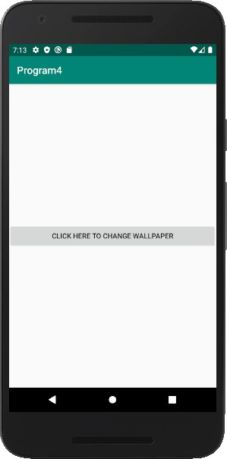
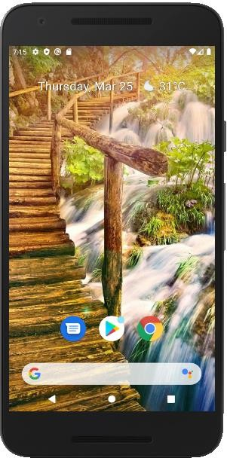

Program 5
Write a program to create an activity with two buttons START and STOP. On Pressing of the START button, the activity must start the counter by displaying the numbers from One and the counter must keep on counting until the STOP button is pressed. Display the counter value in a TextViewcontrol.

- Create a New Android Project with Empty Activity.
- Open activity_main.xml file from res→ layout folder, check/add ConstraintLayout as the root view.
- Create the layout design using Drag and Drop framework.
- Add Listeners to Button Click Event:
  - Create a class which implements OnClickListener interface.
  - Override onClick() method of OnClickListener Interface.
  - Register the button for click event by calling setOnClickListener() method of View class and pass the object of the class that implemented OnClickListener Interface.
- Create a Thread to start the counter logic.
- Steps to Create a Thread
  - Create a class that extends Thread Class.
  - Override run method of Thread Class.
  - Use start() method of thread class to start the thread.
- Create Handler class to receive message from child thread, Handler executes in Main Thread.
- Steps to Create Handler
  - Create Object of type Handler.
  - OverridhandleMessage() of handler class.
- Pass the counter value to be displayed to the handler.
- Update the UI to display the counter value received from thread.

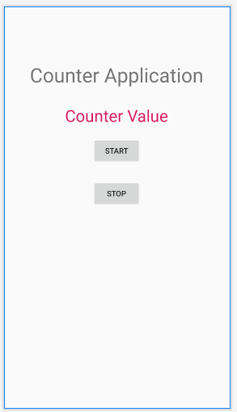
Design

activity_main.xml

<?xml version="1.0" encoding="utf-8"?>
<androidx.constraintlayout.widget.ConstraintLayoutxmlns:android="http://schemas.andr oid.com/apk/res/android"
xmlns:app="http://schemas.android.com/apk/res-auto" xmlns:tools="http://schemas.android.com/tools" android:id="@+id/lbl_counter" android:layout_width="match_parent" android:layout_height="match_parent" tools:context=".MainActivity">

<TextView android:id="@+id/textView" android:layout_width="wrap_content"
android:layout_height="wrap_content" android:layout_marginTop="100dp" android:text="Counter Application" android:textSize="36sp" app:layout_constraintEnd_toEndOf="parent" app:layout_constraintStart_toStartOf="parent" app:layout_constraintTop_toTopOf="parent" />

<TextView android:id="@+id/lbl_text" android:layout_width="wrap_content"
android:layout_height="wrap_content" android:layout_marginTop="30dp" android:text="Counter Value" android:textColor="@color/colorAccent" android:textSize="30sp" app:layout_constraintEnd_toEndOf="parent" app:layout_constraintStart_toStartOf="parent"
app:layout_constraintTop_toBottomOf="@+id/textView" />

<Button android:id="@+id/btn_start"
android:layout_width="wrap_content" android:layout_height="wrap_content" android:layout_marginTop="20dp" android:text="Start" app:layout_constraintEnd_toEndOf="parent" app:layout_constraintStart_toStartOf="parent"
app:layout_constraintTop_toBottomOf="@+id/lbl_text" />

<Button android:id="@+id/btn_stop"
android:layout_width="wrap_content" android:layout_height="wrap_content" android:layout_marginTop="30dp" android:text="Stop" app:layout_constraintEnd_toEndOf="parent" app:layout_constraintStart_toStartOf="parent"
app:layout_constraintTop_toBottomOf="@+id/btn_start" />
</androidx.constraintlayout.widget.ConstraintLayout>

MainActivity.java

package com.example.program5;
import androidx.appcompat.app.AppCompatActivity; import android.os.Bundle;
import android.os.Handler;
import android.os.Message; import android.view.View; import android.widget.Button; import android.widget.TextView;

import org.w3c.dom.Text;
public class MainActivityextendsAppCompatActivityimplementsView.OnClickListener { TextViewlblCounter;
Button btnStart,btnStop;

int counter=0; booleanrunning=false;

@Override
protected void onCreate(Bundle savedInstanceState) { super.onCreate(savedInstanceState); setContentView(R.layout.activity_main); lblCounter=(TextView)findViewById(R.id.lbl_text); btnStart=(Button)findViewById(R.id.btn_start); btnStop=(Button)findViewById(R.id.btn_stop); btnStop.setOnClickListener(this); btnStart.setOnClickListener(this);
}

public void onClick(View v)
{
if(v.equals(btnStart))
{
counter=0; running=true;
new MyCounter().start();
}
else if(v.equals(btnStop))
{
running=false;
}
}

Handler handler=new Handler()
{
public void handleMessage(Message m)
{
lblCounter.setText(String.valueOf(m.what));
}

};

class MyCounterextendsThread
{
public void run()
{
while(running)
{
counter++; handler.sendEmptyMessage(counter);

try { Thread.sleep(1000);
}
catch(Exception e) { }
}
}
}
}

Sample Output

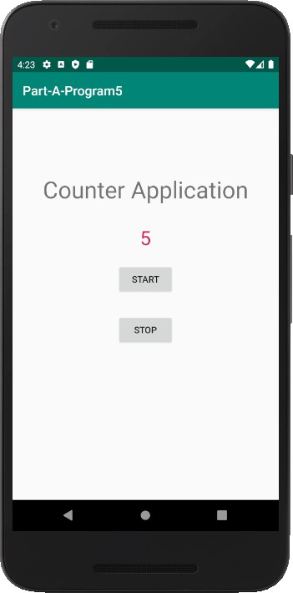

Program 6
Create two files of XML and JSON type with values for City_Name, Latitude, Longitude, Temperature, and Humidity. Develop an application to create an activity with two buttons to parse the XML and JSON files which when clicked should display the data in their respective layouts side by side.

- Create a New Android Project with Empty Activity.
- Open activity_main.xml file from res→ layout folder, check/add ConstraintLayout as the root view.
- Create the layout design using Drag and Drop framework.
- Add Listeners to Button Click Event:
  - Create a class which implements OnClickListener interface.
  - Override onClick() method of OnClickListener Interface.
  - Register the button for click event by calling setOnClickListener() method of View class and pass the object of the class that implemented OnClickListener Interface.
- Create assets folder (Refer Section Android Studio Tutorial)
- Create input.xml file inside assets folder and paste the below Xml Data
<?xml version="1.0"?>
<records>
<employee>

<city_name>Mysore</city_name>
<Latitude>12.295</Latitude>
<Longitude>76.639</Longitude>
<Temperature>22</Temperature>
<Humidity>90%</Humidity>
</employee>
</records>

- Create input.json file inside assets folder and paste the below Json Data
{
"employee": { "city_name": "Mysore", "Latitude": "12.295",
"Longitude": "76.639",
"Temperature": 22,
"Humidity": "90%"
}
}
- Read the XML and Json Data in the files and display on screen

Design

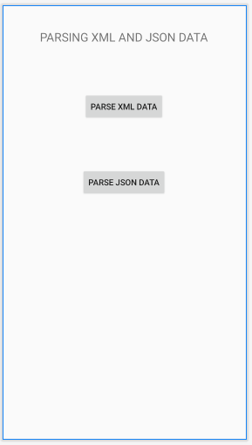
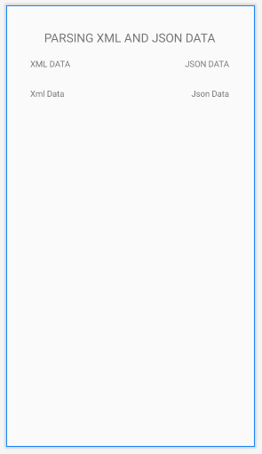

activity_main.xml

<?xml version="1.0" encoding="utf-8"?>
<androidx.constraintlayout.widget.ConstraintLayoutxmlns:android="http://schemas.andr oid.com/apk/res/android"
xmlns:app="http://schemas.android.com/apk/res-auto" xmlns:tools="http://schemas.android.com/tools" android:layout_width="match_parent" android:layout_height="match_parent" tools:context=".MainActivity">

<Button android:id="@+id/btn_parsexml" android:layout_width="wrap_content" android:layout_height="wrap_content" android:layout_marginTop="80dp" android:text="Parse XML Data"
app:layout_constraintEnd_toEndOf="parent" app:layout_constraintStart_toStartOf="parent" app:layout_constraintTop_toBottomOf="@+id/textView4" />

<Button android:id="@+id/btn_parsejson" android:layout_width="wrap_content" android:layout_height="wrap_content" android:layout_marginTop="80dp" android:text="Parse Json Data"
app:layout_constraintEnd_toEndOf="parent" app:layout_constraintStart_toStartOf="parent" app:layout_constraintTop_toBottomOf="@+id/btn_parsexml" />

<TextView android:id="@+id/textView4" android:layout_width="wrap_content" android:layout_height="wrap_content" android:layout_marginTop="40dp"
android:text="PARSING XML AND JSON DATA" android:textSize="20dp" app:layout_constraintEnd_toEndOf="parent" app:layout_constraintStart_toStartOf="parent" app:layout_constraintTop_toTopOf="parent" />
</androidx.constraintlayout.widget.ConstraintLayout>

activity_view.xml

<?xml version="1.0" encoding="utf-8"?>
<androidx.constraintlayout.widget.ConstraintLayoutxmlns:android="http://schemas.andr oid.com/apk/res/android"
xmlns:app="http://schemas.android.com/apk/res-auto" xmlns:tools="http://schemas.android.com/tools" android:layout_width="match_parent" android:layout_height="match_parent" tools:context=".ViewActivity">

<TextView android:id="@+id/lbl_xml_data" android:layout_width="wrap_content" android:layout_height="wrap_content" android:layout_marginTop="30dp" android:text="Xml Data"
app:layout_constraintStart_toStartOf="@+id/textView2" app:layout_constraintTop_toBottomOf="@+id/textView2" />

<TextView android:id="@+id/textView" android:layout_width="wrap_content"
android:layout_height="wrap_content" android:layout_marginTop="40dp" android:text="PARSING XML AND JSON DATA" android:textSize="20dp" app:layout_constraintEnd_toEndOf="parent" app:layout_constraintStart_toStartOf="parent" app:layout_constraintTop_toTopOf="parent" />

<TextView android:id="@+id/textView2" android:layout_width="wrap_content" android:layout_height="wrap_content" android:layout_marginStart="40dp" android:layout_marginTop="20dp" android:text="XML DATA"
app:layout_constraintStart_toStartOf="parent" app:layout_constraintTop_toBottomOf="@+id/textView" />

<TextView android:id="@+id/textView3" android:layout_width="wrap_content" android:layout_height="wrap_content" android:layout_marginTop="20dp" android:layout_marginEnd="40dp" android:text="JSON DATA"
app:layout_constraintEnd_toEndOf="parent" app:layout_constraintTop_toBottomOf="@+id/textView" />

<TextView android:id="@+id/lbl_json_data" android:layout_width="wrap_content" android:layout_height="wrap_content" android:layout_marginTop="30dp" android:text="Json Data"
app:layout_constraintEnd_toEndOf="@+id/textView3" app:layout_constraintTop_toBottomOf="@+id/textView3" />
</androidx.constraintlayout.widget.ConstraintLayout>

MainActivity.java
package com.example.parta_program6;
import androidx.appcompat.app.AppCompatActivity; import android.content.Intent;
import android.os.Bundle; import android.view.View; import android.widget.Button;

public class MainActivityextendsAppCompatActivityimplementsView.OnClickListener { Button btnParseXml,btnParseJson;
@Override
protected void onCreate(Bundle savedInstanceState) { super.onCreate(savedInstanceState); setContentView(R.layout.activity_main); btnParseXml=(Button)findViewById(R.id.btn_parsexml); btnParseJson=(Button)findViewById(R.id.btn_parsejson); btnParseJson.setOnClickListener(this); btnParseXml.setOnClickListener(this);
}

@Override
public void onClick(View v) {

if(v.equals(btnParseJson))
{
Intent it=new Intent(this,ViewActivity.class); it.putExtra("mode",1);
startActivity(it);

}
else if(v.equals(btnParseXml))
{
Intent it=new Intent(this,ViewActivity.class); it.putExtra("mode",2);
startActivity(it);
}
}
}

ViewActivity.java
package com.example.parta_program6;
import androidx.appcompat.app.AppCompatActivity; import android.os.Bundle;
import android.widget.TextView;

import org.json.JSONObject; import org.w3c.dom.Document; import org.w3c.dom.Element; import org.w3c.dom.Node; import org.w3c.dom.NodeList;

import java.io.InputStream;

import javax.xml.parsers.DocumentBuilder; import javax.xml.parsers.DocumentBuilderFactory;

public class ViewActivityextendsAppCompatActivity { TextViewlblXmlData,lblJsonData;
int mode=0; @Override
protected void onCreate(Bundle savedInstanceState) { super.onCreate(savedInstanceState); setContentView(R.layout.activity_view); lblXmlData=(TextView)findViewById(R.id.lbl_xml_data); lblJsonData=(TextView)findViewById(R.id.lbl_json_data); mode=getIntent().getIntExtra("mode",0);

if(mode==1) parseJson();

else parseXmlDocument();

}

public String parseXmlDocument()
{
try {

InputStream is = getAssets().open("input.xml");

DocumentBuilderFactorydbFactory = DocumentBuilderFactory.newInstance(); DocumentBuilderdBuilder = dbFactory.newDocumentBuilder();
Document doc = dBuilder.parse(is);

Element element=doc.getDocumentElement(); element.normalize();

NodeListnList = doc.getElementsByTagName("employee"); for (int i=0; i<nList.getLength(); i++) {
Node node = nList.item(i);
if (node.getNodeType() == Node.ELEMENT_NODE) { Element element2 = (Element) node;
lblXmlData.setText("City Name : " + getValue("city_name", element2)+"\n"); lblXmlData.append("Latitude : " + getValue("Latitude", element2)+"\n"); lblXmlData.append("Longitude : " + getValue("Longitude", element2)+"\n"); lblXmlData.append("Temperature : " + getValue("Temperature", element2)+"\n"); lblXmlData.append("Humidity : " + getValue("Humidity", element2)+"\n");

}
}
}
catch (Exception e) {e.printStackTrace();} return null;
}

private static String getValue(String tag, Element element) { NodeListnodeList = element.getElementsByTagName(tag).item(0).getChildNodes(); Node node = nodeList.item(0);
return node.getNodeValue();
}

public void parseJson()
{
try { InputStreaminputStream=getAssets().open("input.json"); byte[] data=new byte[inputStream.available()]; inputStream.read(data);

String readData=new String(data); JSONObjectjsonObject=new JSONObject(readData);
JSONObject jsonObject1=jsonObject.getJSONObject("employee"); lblJsonData.setText("City Name:"+jsonObject1.getString("city_name")+"\n"); lblJsonData.append("Latitude:"+jsonObject1.getString("Latitude")+"\n"); lblJsonData.append("Longitude"+jsonObject1.getString("Longitude")+"\n"); lblJsonData.append("Temperature:"+jsonObject1.getInt("Temperature")+"\n"); lblJsonData.append("Humidity"+jsonObject1.getString("Humidity")+"\n");

}
catch (Exception e) {e.printStackTrace();}
}
}

Sample Output

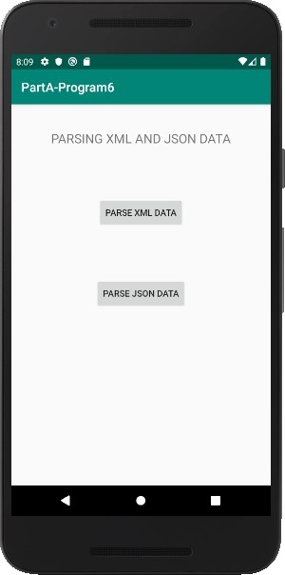
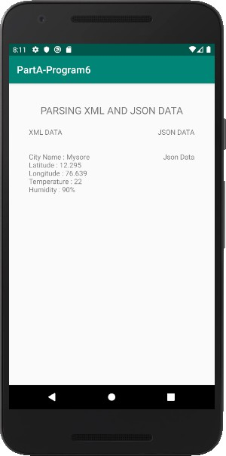
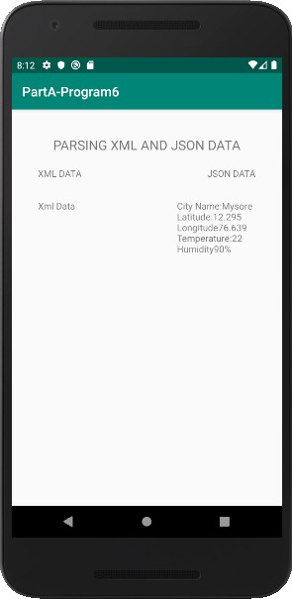

Program 7
Develop a simple application with one EditText so that the user can write some text in it. Create a button called “Convert Text to Speech” that converts the user input text into voice.

- Create a New Android Project with Empty Activity.
- Open activity_main.xml file from res→ layout folder, check/add ConstraintLayout as the root view.
- Create the layout design using Drag and Drop framework.
- Add Listeners to Button Click Event:
  - Create a class which implments OnClickListener interface.
  - Override onClick() method of OnClickListener Interface.
  - Register the button for click event by calling setOnClickListener() method of View class and pass the object of the class that implemented OnClickListener Interface.
- Initialize TextToSpeech Engine and the Language to Speak using setLanguage() method
- Use Speak() method to speak the text passed to it.

Design
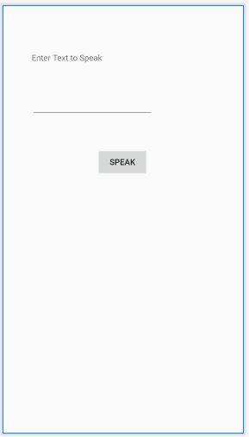

activity_main.xml

<?xml version="1.0" encoding="utf-8"?>
<androidx.constraintlayout.widget.ConstraintLayoutxmlns:android="http://schemas.andr oid.com/apk/res/android"
xmlns:app="http://schemas.android.com/apk/res-auto" xmlns:tools="http://schemas.android.com/tools" android:id="@+id/txt_texttospeak" android:layout_width="match_parent" android:layout_height="match_parent" tools:context=".MainActivity">

<TextView android:id="@+id/textView" android:layout_width="wrap_content"
android:layout_height="wrap_content" android:layout_marginStart="50dp" android:layout_marginTop="80dp" android:text="Enter Text to Speak" app:layout_constraintStart_toStartOf="parent" app:layout_constraintTop_toTopOf="parent" />

<EditText android:id="@+id/editText" android:layout_width="wrap_content"
android:layout_height="wrap_content" android:layout_marginTop="48dp" android:ems="10" android:inputType="textPersonName" app:layout_constraintEnd_toEndOf="parent" app:layout_constraintHorizontal_bias="0.0"
app:layout_constraintStart_toStartOf="@+id/textView" app:layout_constraintTop_toBottomOf="@+id/textView" />

<Button android:id="@+id/btn_speak"
android:layout_width="wrap_content" android:layout_height="wrap_content" android:layout_marginTop="52dp" android:text="Speak" app:layout_constraintEnd_toEndOf="parent" app:layout_constraintStart_toStartOf="parent"
app:layout_constraintTop_toBottomOf="@+id/editText" />
</androidx.constraintlayout.widget.ConstraintLayout>

MainActivity.java

package com.example.parta.parta_program7; import androidx.appcompat.app.AppCompatActivity;
import android.os.Bundle;
import android.speech.tts.TextToSpeech; import android.view.View;
import android.widget.Button; import android.widget.EditText; import android.widget.Toast;

import java.util.Locale;
public class MainActivityextendsAppCompatActivityimplementsView.OnClickListener { EditTexttxtSpeak;
Button btnSpeak;
TextToSpeechtextToSpeech;

@Override
protected void onCreate(Bundle savedInstanceState) { super.onCreate(savedInstanceState); setContentView(R.layout.activity_main); txtSpeak=(EditText)findViewById(R.id.editText); btnSpeak=(Button)findViewById(R.id.btn_speak); btnSpeak.setOnClickListener(this);
textToSpeech=new TextToSpeech(getBaseContext(), new TextToSpeech.OnInitListener() {
@Override
public void onInit(int status) { if(status!=TextToSpeech.ERROR)
{
Toast.makeText(getBaseContext(),"Success", Toast.LENGTH_LONG).show();
}
}
});
textToSpeech.setLanguage(Locale.UK);
}

public void onClick(View v)
{
String text=txtSpeak.getText().toString(); textToSpeech.speak(text,TextToSpeech.QUEUE_FLUSH,null);

}
}

Sample Output

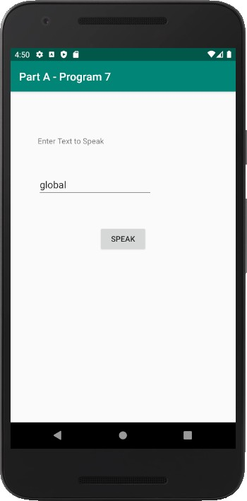

Program 8
Create an activity like a phone dialer with CALL and SAVE buttons. On pressing the CALL button, it must call the phone number and on pressing the SAVE button it must save the number to the phone contacts.

- Create a New Android Project with Empty Activity.
- Open activity_main.xml file from res→ layout folder, check/add ConstraintLayout as the root view.
- Create the layout design using Drag and Drop framework.
- Add Listeners to Button Click Event:
  - Create a class which implments OnClickListener interface.
  - Override onClick() method of OnClickListener Interface.
  - Register the button for click event by calling setOnClickListener() method of View class and pass the object of the class that implemented OnClickListener Interface.
- Declare uses permission android.permission.CALL_PHONE in the manifest file.
- Use ACTION_CALL intent name and pass the “tel:<phone-number> as URI in intent data and start the call activity.
- Use intent name and pass the “Telephone Number” and “unknown” as name as intent data call Contacts Save Activity.

Design

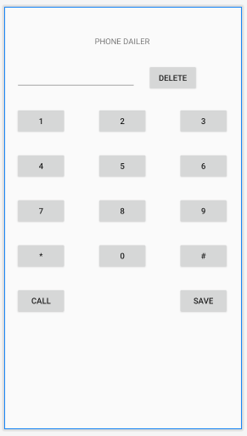

activity_main.xml

<?xml version="1.0" encoding="utf-8"?>
<androidx.constraintlayout.widget.ConstraintLayoutxmlns:android="http://schemas.andr oid.com/apk/res/android"
xmlns:app="http://schemas.android.com/apk/res-auto" xmlns:tools="http://schemas.android.com/tools" android:layout_width="match_parent" android:layout_height="match_parent" tools:context=".MainActivity">

<TextView android:id="@+id/textView" android:layout_width="wrap_content"
android:layout_height="wrap_content" android:layout_marginTop="50dp" android:text="PHONE DAILER" app:layout_constraintEnd_toEndOf="parent" app:layout_constraintStart_toStartOf="parent" app:layout_constraintTop_toTopOf="parent" />

<EditText android:id="@+id/txt_phonenumber" android:layout_width="wrap_content" android:layout_height="wrap_content" android:layout_marginStart="20dp" android:layout_marginTop="30dp" android:ems="10" android:inputType="textPersonName"
app:layout_constraintStart_toStartOf="parent" app:layout_constraintTop_toBottomOf="@+id/textView" />

<Button android:id="@+id/btn_delete" android:layout_width="wrap_content"
android:layout_height="wrap_content" android:layout_marginStart="20dp" android:layout_marginTop="30dp" android:text="Delete"
app:layout_constraintStart_toEndOf="@+id/txt_phonenumber" app:layout_constraintTop_toBottomOf="@+id/textView" />

<Button android:id="@+id/btn_one"
android:layout_width="wrap_content" android:layout_height="wrap_content" android:layout_marginStart="20dp" android:layout_marginTop="30dp" android:text="1" app:layout_constraintStart_toStartOf="parent"
app:layout_constraintTop_toBottomOf="@+id/txt_phonenumber" />

<Button android:id="@+id/btn_two"
android:layout_width="wrap_content" android:layout_height="wrap_content" android:layout_marginTop="30dp" android:text="2"

app:layout_constraintEnd_toStartOf="@+id/btn_three" app:layout_constraintStart_toEndOf="@+id/btn_one" app:layout_constraintTop_toBottomOf="@+id/txt_phonenumber" />

<Button android:id="@+id/btn_three"
android:layout_width="wrap_content" android:layout_height="wrap_content" android:layout_marginTop="30dp" android:layout_marginEnd="20dp" android:text="3" app:layout_constraintEnd_toEndOf="parent"
app:layout_constraintTop_toBottomOf="@+id/txt_phonenumber" />

<Button android:id="@+id/btn_four"
android:layout_width="wrap_content" android:layout_height="wrap_content" android:layout_marginStart="20dp" android:layout_marginTop="30dp" android:text="4" app:layout_constraintStart_toStartOf="parent"
app:layout_constraintTop_toBottomOf="@+id/btn_one" />

<Button android:id="@+id/btn_five"
android:layout_width="wrap_content" android:layout_height="wrap_content" android:layout_marginTop="30dp" android:text="5"
app:layout_constraintEnd_toStartOf="@+id/btn_six" app:layout_constraintStart_toEndOf="@+id/btn_four" app:layout_constraintTop_toBottomOf="@+id/btn_two" />

<Button android:id="@+id/btn_six"
android:layout_width="wrap_content" android:layout_height="wrap_content" android:layout_marginTop="30dp" android:layout_marginEnd="20dp" android:text="6" app:layout_constraintEnd_toEndOf="parent"
app:layout_constraintTop_toBottomOf="@+id/btn_three" />

<Button android:id="@+id/btn_seven"
android:layout_width="wrap_content" android:layout_height="wrap_content" android:layout_marginStart="20dp" android:layout_marginTop="30dp" android:text="7" app:layout_constraintStart_toStartOf="parent"
app:layout_constraintTop_toBottomOf="@+id/btn_four" />

<Button android:id="@+id/btn_eight"
android:layout_width="wrap_content" android:layout_height="wrap_content" android:layout_marginTop="30dp"

android:text="8" app:layout_constraintEnd_toStartOf="@+id/btn_nine" app:layout_constraintStart_toEndOf="@+id/btn_seven" app:layout_constraintTop_toBottomOf="@+id/btn_five" />

<Button android:id="@+id/btn_nine"
android:layout_width="wrap_content" android:layout_height="wrap_content" android:layout_marginTop="30dp" android:layout_marginEnd="20dp" android:text="9" app:layout_constraintEnd_toEndOf="parent"
app:layout_constraintTop_toBottomOf="@+id/btn_six" />

<Button android:id="@+id/btn_zero"
android:layout_width="wrap_content" android:layout_height="wrap_content" android:layout_marginTop="30dp" android:text="0" app:layout_constraintEnd_toEndOf="parent" app:layout_constraintStart_toStartOf="parent"
app:layout_constraintTop_toBottomOf="@+id/btn_eight" />

<Button android:id="@+id/btn_call"
android:layout_width="wrap_content" android:layout_height="wrap_content" android:layout_marginStart="20dp" android:layout_marginTop="30dp" android:text="Call" app:layout_constraintStart_toStartOf="parent"
app:layout_constraintTop_toBottomOf="@+id/btn_zero" />

<Button android:id="@+id/btn_save"
android:layout_width="wrap_content" android:layout_height="wrap_content" android:layout_marginTop="30dp" android:layout_marginEnd="20dp" android:text="Save" app:layout_constraintEnd_toEndOf="parent"
app:layout_constraintTop_toBottomOf="@+id/btn_zero" />

<Button android:id="@+id/btn_start"
android:layout_width="wrap_content" android:layout_height="wrap_content" android:layout_marginStart="20dp" android:layout_marginTop="30dp" android:text="*" app:layout_constraintStart_toStartOf="parent"
app:layout_constraintTop_toBottomOf="@+id/btn_seven" />

<Button android:id="@+id/btn_hash"
android:layout_width="wrap_content" android:layout_height="wrap_content"

android:layout_marginTop="30dp" android:layout_marginEnd="20dp" android:text="#" app:layout_constraintEnd_toEndOf="parent"
app:layout_constraintTop_toBottomOf="@+id/btn_nine" />
</androidx.constraintlayout.widget.ConstraintLayout>

MainActivity.java

package com.example.part_a_program_8;

import androidx.appcompat.app.AppCompatActivity; import android.content.Intent;
import android.net.Uri; import android.os.Bundle;
import android.provider.ContactsContract; import android.view.View;
import android.widget.Button; import android.widget.EditText;
public class MainActivityextends AppCompatActivityimplements View.OnClickListener{ Button btnOne,btnTwo,btnThree,btnFour,btnFive;
Button btnSix,btnSeven,btnEight,btnNine,btnZero; Button btnDel,btnStar,btnHash,btnCall,btnSave;
EditTexttxtPhonenumber; @Override
protected void onCreate(Bundle savedInstanceState) { super.onCreate(savedInstanceState); setContentView(R.layout.activity_main);

btnOne=(Button)findViewById(R.id.btn_one); btnOne.setOnClickListener(this);

btnTwo=(Button)findViewById(R.id.btn_two); btnTwo.setOnClickListener(this);

btnThree=(Button)findViewById(R.id.btn_three); btnThree.setOnClickListener(this);

btnFour=(Button)findViewById(R.id.btn_four); btnFour.setOnClickListener(this);

btnFive=(Button)findViewById(R.id.btn_five); btnFive.setOnClickListener(this);

btnSix=(Button)findViewById(R.id.btn_six); btnSix.setOnClickListener(this);

btnSeven=(Button)findViewById(R.id.btn_seven); btnSeven.setOnClickListener(this);

btnEight=(Button)findViewById(R.id.btn_eight); btnEight.setOnClickListener(this);

btnNine=(Button)findViewById(R.id.btn_nine); btnNine.setOnClickListener(this);

btnZero=(Button)findViewById(R.id.btn_zero); btnZero.setOnClickListener(this);

btnStar=(Button)findViewById(R.id.btn_start); btnStar.setOnClickListener(this);

btnHash=(Button)findViewById(R.id.btn_hash); btnHash.setOnClickListener(this);

btnCall=(Button)findViewById(R.id.btn_call); btnCall.setOnClickListener(this);

btnSave=(Button)findViewById(R.id.btn_save); btnSave.setOnClickListener(this);

btnDel=(Button)findViewById(R.id.btn_delete); btnDel.setOnClickListener(this);
txtPhonenumber=(EditText)findViewById(R.id.txt_phonenumber); txtPhonenumber.setText("");
}

public void onClick(View v)
{
if(v.equals(btnOne)) txtPhonenumber.append("1");

else if(v.equals(btnTwo)) txtPhonenumber.append("2");

else if(v.equals(btnThree)) txtPhonenumber.append("3");

else if(v.equals(btnFour)) txtPhonenumber.append("4");

else if(v.equals(btnFive)) txtPhonenumber.append("5");

else if(v.equals(btnSix)) txtPhonenumber.append("6");

else if(v.equals(btnSeven)) txtPhonenumber.append("7");

else if(v.equals(btnEight)) txtPhonenumber.append("8");

else if(v.equals(btnNine)) txtPhonenumber.append("9");

else if(v.equals(btnZero)) txtPhonenumber.append("0");

else if(v.equals(btnStar)) txtPhonenumber.append("*");

else if(v.equals(btnHash)) txtPhonenumber.append("#");

else if(v.equals(btnSave))
{
Intent contactIntent= new Intent
(ContactsContract.Intents.Insert.ACTION); contactIntent.setType
(ContactsContract.RawContacts.CONTENT_TYPE);

contactIntent
.putExtra(ContactsContract.Intents.Insert.NAME,"Unknown"); contactIntent.putExtra(ContactsContract.Intents.Insert.PHONE, txtPhonenumber.getText().toString());

startActivity(contactIntent);

}

else if(v.equals(btnDel))
{
String data=txtPhonenumber.getText().toString(); if(data.length()>0)
{
txtPhonenumber.setText
(data.substring(0,data.length()-1));

}
else
{
txtPhonenumber.setText("");
}
}

btnCall.setOnClickListener(new View.OnClickListener()
{
@Override
public void onClick(View v) {

String data = txtPhonenumber.getText().toString(); Intent intent=new Intent(Intent.ACTION_DIAL); intent.setData(Uri.parse("tel:"+ data)); startActivity(intent);
}
}
);

}

}

AndriodManifest.xml
<?xml version="1.0" encoding="utf-8"?>
<manifest xmlns:android="http://schemas.android.com/apk/res/android" package="com.example.part_a_program_8">

<uses-permission android:name="android.permission.CALL_PHONE"/>

<application android:allowBackup="true" android:icon="@mipmap/ic_launcher" android:label="@string/app_name"
android:roundIcon="@mipmap/ic_launcher_round" android:supportsRtl="true" android:theme="@style/AppTheme">
<activity android:name=".MainActivity">
<intent-filter>
<action android:name="android.intent.action.MAIN" />

<category android:name="android.intent.category.LAUNCHER" />
</intent-filter>
</activity>
</application>

</manifest>

Sample Output
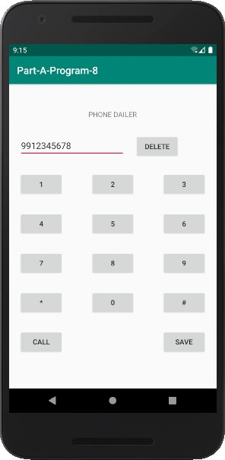
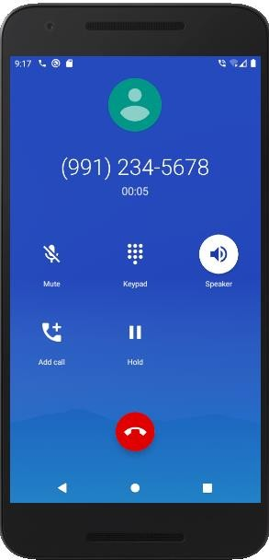

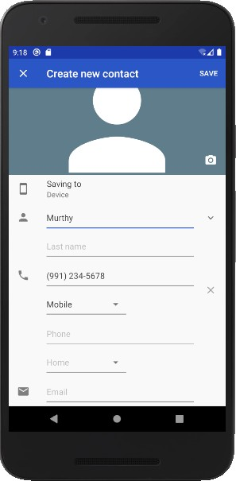
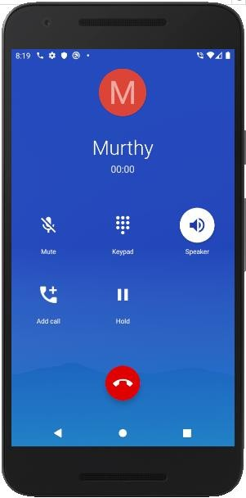

PART B

Part B programs should be developed as an application and are to be demonstrated as a mini project in a group by adding extra features or the students can also develop their application and demonstrate it as a mini-project. (Projects/programs are not limited to the list given in Part B).

Program 1
Write a program to enter Medicine Name, Date and Time of the Day as input from the user and store it in the SQLite database. Input for Time of the Day should be either Morning or Afternoon or Evening or Night. Trigger an alarm based on the Date and Time of the Day and display the Medicine Name.

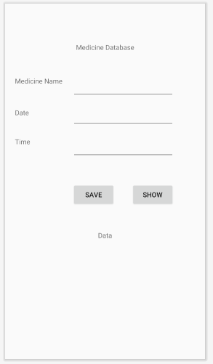
Design
activity_main.xml

<?xml version="1.0" encoding="utf-8"?>
<androidx.constraintlayout.widget.ConstraintLayoutxmlns:android="http://schemas.andr oid.com/apk/res/android"
xmlns:app="http://schemas.android.com/apk/res-auto" xmlns:tools="http://schemas.android.com/tools" android:layout_width="match_parent" android:layout_height="match_parent" tools:context=".MainActivity">

<TextView android:id="@+id/textView2" android:layout_width="wrap_content" android:layout_height="wrap_content" android:layout_marginTop="80dp" android:text="Medicine Database"
app:layout_constraintEnd_toEndOf="parent" app:layout_constraintStart_toStartOf="parent" app:layout_constraintTop_toTopOf="parent" />

<TextView android:id="@+id/textView3" android:layout_width="wrap_content" android:layout_height="wrap_content" android:layout_marginStart="20dp" android:text="Medicine Name"
app:layout_constraintStart_toStartOf="parent" app:layout_constraintTop_toTopOf="@+id/txt_medicine_name" />

<TextView android:id="@+id/textView4" android:layout_width="wrap_content" android:layout_height="wrap_content" android:layout_marginStart="20dp" android:text="Date"
app:layout_constraintBottom_toBottomOf="@+id/txt_date" app:layout_constraintStart_toStartOf="parent" app:layout_constraintTop_toBottomOf="@+id/txt_medicine_name" />

<TextView android:id="@+id/textView5" android:layout_width="wrap_content" android:layout_height="wrap_content" android:layout_marginStart="20dp" android:text="Time"
app:layout_constraintStart_toStartOf="parent" app:layout_constraintTop_toTopOf="@+id/txt_time" />

<EditText android:id="@+id/txt_medicine_name" android:layout_width="wrap_content" android:layout_height="wrap_content" android:layout_marginStart="20dp" android:layout_marginTop="50dp" android:ems="10" android:inputType="textPersonName"
app:layout_constraintStart_toEndOf="@+id/textView3" app:layout_constraintTop_toBottomOf="@+id/textView2" />

<EditText android:id="@+id/txt_date" android:layout_width="wrap_content" android:layout_height="wrap_content" android:layout_marginTop="15dp" android:ems="10" android:inputType="textPersonName"
app:layout_constraintStart_toStartOf="@+id/txt_medicine_name" app:layout_constraintTop_toBottomOf="@+id/txt_medicine_name" />

<EditText android:id="@+id/txt_time" android:layout_width="wrap_content"
android:layout_height="wrap_content" android:layout_marginTop="20dp" android:ems="10" android:inputType="textPersonName"
app:layout_constraintStart_toStartOf="@+id/txt_date" app:layout_constraintTop_toBottomOf="@+id/txt_date" />

<Button android:id="@+id/btn_save"
android:layout_width="wrap_content" android:layout_height="wrap_content" android:layout_marginTop="50dp" android:text="Save"
app:layout_constraintStart_toStartOf="@+id/txt_time" app:layout_constraintTop_toBottomOf="@+id/txt_time" />

<Button android:id="@+id/btn_show"
android:layout_width="wrap_content" android:layout_height="wrap_content" android:layout_marginTop="50dp" android:text="Show" app:layout_constraintEnd_toEndOf="@+id/txt_time"
app:layout_constraintTop_toBottomOf="@+id/txt_time" />

<TextView android:id="@+id/lbl_data" android:layout_width="wrap_content"
android:layout_height="wrap_content" android:layout_marginTop="50dp" android:text="Data" app:layout_constraintEnd_toEndOf="parent" app:layout_constraintStart_toStartOf="parent"
app:layout_constraintTop_toBottomOf="@+id/btn_save" />
</androidx.constraintlayout.widget.ConstraintLayout>

MyDatabase.java
package com.example.partb_program1; import android.content.Context;
import android.database.sqlite.SQLiteDatabase; import android.database.sqlite.SQLiteOpenHelper;

import androidx.annotation.Nullable;

public class MyDatabaseextends SQLiteOpenHelper { public static String DATABASE_NAME="medicine.db";
public MyDatabase(@Nullable Context context, @Nullable String name, @Nullable SQLiteDatabase.CursorFactory factory, int version) {
super(context, name, factory, version);
}

@Override
public void onCreate(SQLiteDatabasedb) {

db.execSQL("CREATE TABLE MEDICINE_NAMES (NAME TEXT,MDATE TEXT,MTIME TEXT)");

}

@Override
public void onUpgrade(SQLiteDatabasedb, int oldVersion, int newVersion) {

}
}

MainActivity.java
package com.example.partb_program1;
import androidx.appcompat.app.AppCompatActivity; import android.content.ContentValues;
import android.database.Cursor;
import android.database.sqlite.SQLiteDatabase; import android.os.Bundle;
import android.view.View; import android.widget.Button; import android.widget.EditText; import android.widget.TextView; import android.widget.Toast;

import org.w3c.dom.Text;
public class MainActivityextends AppCompatActivityimplements View.OnClickListener { EditTexttxtMedicineName,txtDate,txtTime;
Button btnSave,btnShow; TextViewlblData;
MyDatabasemyDatabase; @Override
protected void onCreate(Bundle savedInstanceState) {
super.onCreate(savedInstanceState); setContentView(R.layout.activity_main); txtMedicineName=(EditText)findViewById(R.id.txt_medicine_name); txtDate=(EditText)findViewById(R.id.txt_date); txtTime=(EditText)findViewById(R.id.txt_time);

btnSave=(Button)findViewById(R.id.btn_save); btnSave.setOnClickListener(this); btnShow=(Button)findViewById(R.id.btn_show); btnShow.setOnClickListener(this); lblData=(TextView)findViewById(R.id.lbl_data);

myDatabase=new MyDatabase(getBaseContext(), MyDatabase.DATABASE_NAME,null,1);

}

public void onClick(View v)
{
if(v.equals(btnSave))
{
String medicineName= txtMedicineName.getText().toString(); String date=txtDate.getText().toString();
String time=txtTime.getText().toString();

SQLiteDatabase database=myDatabase.getWritableDatabase(); ContentValues cv=new ContentValues(); cv.put("NAME",medicineName);
cv.put("MDATE",date);
cv.put("MTIME",time);

database.insert("MEDICINE_NAMES",null,cv); Toast.makeText(getBaseContext(),"Data Saved",Toast.LENGTH_LONG).show();
}
else if(v.equals(btnShow))
{

SQLiteDatabase database=myDatabase.getReadableDatabase(); Cursor cursor= database.query("MEDICINE_NAMES",
new String[]{"NAME","MDATE","MTIME"},null,null,null,null,null); lblData.setText("NAME\tDATE\tTIME\n"); while(cursor.moveToNext())
{
lblData.append(cursor.getString(0)+"\t"); lblData.append(cursor.getString(1)+"\t"); lblData.append(cursor.getString(2)+"\n");
}
}
}
}

Sample Output
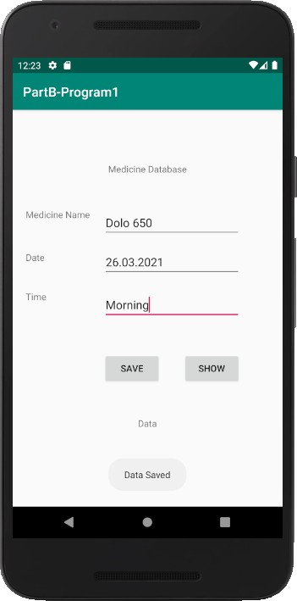
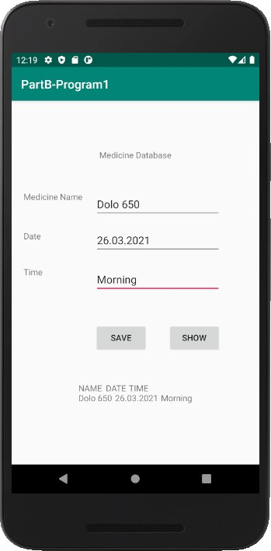

Program 7
Develop an application that makes use of the clipboard framework for copying and pasting of thetext. The activity consists of two EditText controls and two Buttons to trigger the copy and pastefunctionality.

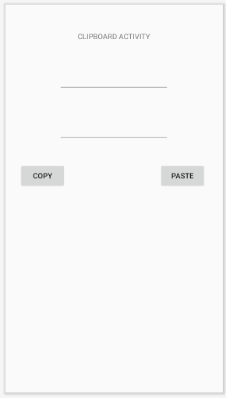
Design

activity_main.xml

<?xml version="1.0" encoding="utf-8"?>
<androidx.constraintlayout.widget.ConstraintLayoutxmlns:android="http://schemas.andr oid.com/apk/res/android"
xmlns:app="http://schemas.android.com/apk/res-auto" xmlns:tools="http://schemas.android.com/tools" android:id="@+id/layout" android:layout_width="match_parent" android:layout_height="match_parent" tools:context=".MainActivity">

<Button android:id="@+id/btn_create" android:layout_width="wrap_content" android:layout_height="wrap_content" android:layout_marginStart="10dp" android:layout_marginTop="40dp" android:text="Create"
app:layout_constraintEnd_toStartOf="@+id/textView2" app:layout_constraintStart_toStartOf="parent" app:layout_constraintTop_toBottomOf="@+id/textView2" />

<Button android:id="@+id/btn_open"
android:layout_width="wrap_content" android:layout_height="wrap_content" android:layout_marginTop="40dp" android:layout_marginEnd="10dp" android:text="Open" app:layout_constraintEnd_toEndOf="parent" app:layout_constraintStart_toEndOf="@+id/textView2"
app:layout_constraintTop_toBottomOf="@+id/textView2" />

<TextView android:id="@+id/textView2" android:layout_width="wrap_content" android:layout_height="wrap_content" android:layout_marginTop="50dp" android:text="File Application"
app:layout_constraintEnd_toEndOf="parent" app:layout_constraintStart_toStartOf="parent" app:layout_constraintTop_toTopOf="parent" />

<EditText android:id="@+id/txt_content" android:layout_width="272dp" android:layout_height="138dp" android:layout_marginTop="50dp" android:ems="10" android:inputType="textPersonName"
app:layout_constraintTop_toBottomOf="@+id/btn_create" tools:layout_editor_absoluteX="65dp" />

<Button android:id="@+id/btn_save"
android:layout_width="wrap_content"

android:layout_height="wrap_content" android:layout_marginTop="50dp" android:text="Save" app:layout_constraintEnd_toEndOf="parent" app:layout_constraintStart_toStartOf="parent"
app:layout_constraintTop_toBottomOf="@+id/txt_content" />
</androidx.constraintlayout.widget.ConstraintLayout>

MainActivity.java

package com.example.partbprogram7;

import androidx.appcompat.app.AppCompatActivity; import android.content.ClipData;
import android.content.ClipboardManager; import android.os.Bundle;
import android.view.View; import android.widget.Button; import android.widget.EditText; import android.widget.Toast;

public class MainActivityextends AppCompatActivityimplements View.OnClickListener { EditTexttxtCopy,txtPaste;
Button btnCopy,btnPaste; ClipboardManagermyClipboard;
@Override
protected void onCreate(Bundle savedInstanceState) { super.onCreate(savedInstanceState); setContentView(R.layout.activity_main); txtCopy=(EditText)findViewById(R.id.txt_copy); txtPaste=(EditText)findViewById(R.id.txt_paste);

btnCopy=(Button)findViewById(R.id.btn_copy); btnCopy.setOnClickListener(this);

btnPaste=(Button)findViewById(R.id.btn_paste); btnPaste.setOnClickListener(this);

myClipboard= (ClipboardManager)getSystemService(CLIPBOARD_SERVICE);
}

@Override
public void onClick(View v) { if(v.equals(btnCopy))
{
ClipDatamyClip;
String data = txtCopy.getText().toString(); myClip = ClipData.newPlainText("text", data); myClipboard.setPrimaryClip(myClip);
Toast.makeText(getBaseContext(),"Copied..",Toast.LENGTH_LONG).show();
}

else if(v.equals(btnPaste))
{
ClipDataabc = myClipboard.getPrimaryClip(); ClipData.Item item = abc.getItemAt(0); txtPaste.setText(item.getText().toString());
}
}
}

AndroidManifest.xml

<?xml version="1.0" encoding="utf-8"?>
<manifest xmlns:android="http://schemas.android.com/apk/res/android" package="com.example.partbprogram7">

<application android:allowBackup="true" android:icon="@mipmap/ic_launcher" android:label="@string/app_name"
android:roundIcon="@mipmap/ic_launcher_round" android:supportsRtl="true" android:theme="@style/AppTheme">
<activity android:name=".MainActivity">
<intent-filter>
<action android:name="android.intent.action.MAIN" />
<category android:name="android.intent.category.LAUNCHER" />
</intent-filter>
</activity>
</application>
</manifest>

Sample Output
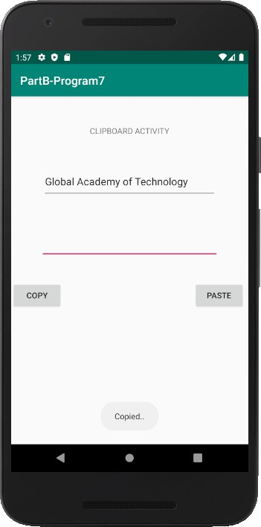
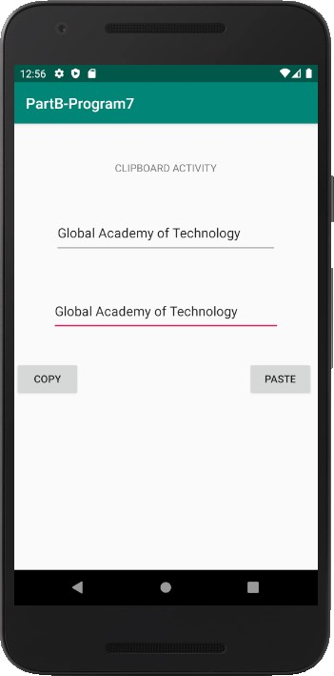

Program 8
Create an AIDL service that calculates Car Loan EMI. The formula to calculate EMI is
E = P * (r(1+r)^{n})/((1+r)^{n}-1)
where
E = The EMI payable on the car loan amount P = The Car loan Principal Amount
r = The interest rate value computed on a monthly basis n = The loan tenure in the form of months
The down payment amount has to be deducted from the principal amount paid towards buying theCar. Develop an application that makes use of this AIDL service to calculate the EMI. Thisapplication should have four EditText to read the PrincipalAmount, Down Payment, Interest Rate,Loan Term (in months) and a button named as “Calculate Monthly EMI”. On click of this button,the result should be shown in a TextView. Also, calculate the EMI by varying the Loan Term andInterest Rate values.

Design
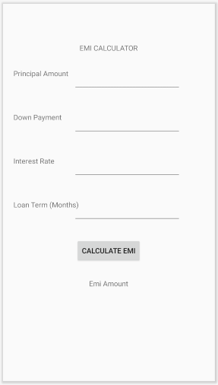

activity_main.xml

<?xml version="1.0" encoding="utf-8"?>
<androidx.constraintlayout.widget.ConstraintLayoutxmlns:android="http://schemas.andr oid.com/apk/res/android"
xmlns:app="http://schemas.android.com/apk/res-auto" xmlns:tools="http://schemas.android.com/tools" android:id="@+id/lblpayment" android:layout_width="match_parent" android:layout_height="match_parent" tools:context=".MainActivity">

<TextView android:id="@+id/textView" android:layout_width="wrap_content"
android:layout_height="wrap_content" android:text="EMI CALCULATOR" app:layout_constraintEnd_toEndOf="parent" app:layout_constraintStart_toStartOf="parent" tools:layout_editor_absoluteY="76dp" />

<TextView android:id="@+id/textView2" android:layout_width="wrap_content" android:layout_height="wrap_content" android:layout_marginStart="20dp" android:layout_marginTop="30dp" android:text="Principal Amount"
app:layout_constraintStart_toStartOf="parent" app:layout_constraintTop_toBottomOf="@+id/textView" />

<EditText android:id="@+id/txt_principal" android:layout_width="wrap_content" android:layout_height="wrap_content" android:layout_marginStart="10dp" android:layout_marginTop="30dp" android:ems="10" android:inputType="textPersonName"
app:layout_constraintStart_toEndOf="@+id/textView2" app:layout_constraintTop_toBottomOf="@+id/textView" />

<TextView android:id="@+id/downpayment" android:layout_width="wrap_content" android:layout_height="wrap_content" android:text="Down Payment"
app:layout_constraintStart_toStartOf="@+id/textView2" app:layout_constraintTop_toTopOf="@+id/txt_downnpayment" />

<EditText android:id="@+id/txt_downnpayment" android:layout_width="wrap_content" android:layout_height="wrap_content" android:layout_marginTop="40dp" android:ems="10" android:inputType="textPersonName"
app:layout_constraintStart_toStartOf="@+id/txt_principal"

app:layout_constraintTop_toBottomOf="@+id/txt_principal" />

<TextView android:id="@+id/textView4" android:layout_width="wrap_content" android:layout_height="wrap_content" android:text="Interest Rate"
app:layout_constraintStart_toStartOf="@+id/downpayment" app:layout_constraintTop_toTopOf="@+id/txt_interestrate" />

<EditText android:id="@+id/txt_interestrate" android:layout_width="wrap_content" android:layout_height="wrap_content" android:layout_marginTop="40dp" android:ems="10" android:inputType="textPersonName"
app:layout_constraintStart_toStartOf="@+id/txt_downnpayment" app:layout_constraintTop_toBottomOf="@+id/txt_downnpayment" />

<TextView android:id="@+id/textView5" android:layout_width="130dp" android:layout_height="33dp" android:layout_marginTop="8dp" android:text="Loan Term (Months)"
app:layout_constraintStart_toStartOf="@+id/textView4" app:layout_constraintTop_toTopOf="@+id/txt_termmonths" />

<EditText android:id="@+id/txt_termmonths" android:layout_width="wrap_content" android:layout_height="wrap_content" android:layout_marginStart="20dp" android:layout_marginTop="32dp" android:ems="10" android:inputType="textPersonName"
app:layout_constraintStart_toStartOf="@+id/txt_interestrate" app:layout_constraintTop_toBottomOf="@+id/txt_interestrate" />

<Button android:id="@+id/btn_calculate" android:layout_width="wrap_content" android:layout_height="wrap_content" android:layout_marginTop="30dp" android:text="Calculate EMI"
app:layout_constraintEnd_toEndOf="parent" app:layout_constraintStart_toStartOf="parent" app:layout_constraintTop_toBottomOf="@+id/txt_termmonths" />

<TextView android:id="@+id/lbl_emiamount" android:layout_width="wrap_content" android:layout_height="wrap_content" android:layout_marginTop="30dp" android:text="Emi Amount"
app:layout_constraintEnd_toEndOf="parent" app:layout_constraintStart_toStartOf="parent"

app:layout_constraintTop_toBottomOf="@+id/btn_calculate" />

</androidx.constraintlayout.widget.ConstraintLayout>

MainActivity.java

package com.example.partb_program8;

import androidx.appcompat.app.AppCompatActivity; import android.os.Bundle;
import android.view.View; import android.widget.Button; import android.widget.EditText; import android.widget.TextView; import android.widget.Toast;

import java.text.DecimalFormat;
import java.util.logging.SimpleFormatter;

public class MainActivityextends AppCompatActivityimplements View.OnClickListener { EditTexttxtPrinicple,txtDownPayment,txtInterestRate,txtLoanTerm;
Button btnCalculate; TextViewlblResult;
@Override
protected void onCreate(Bundle savedInstanceState) { super.onCreate(savedInstanceState); setContentView(R.layout.activity_main); txtPrinicple=(EditText)findViewById(R.id.txt_principal); txtDownPayment=(EditText)findViewById(R.id.txt_downnpayment); txtInterestRate=(EditText)findViewById(R.id.txt_interestrate); txtLoanTerm=(EditText)findViewById(R.id.txt_termmonths);

btnCalculate=(Button)findViewById(R.id.btn_calculate); btnCalculate.setOnClickListener(this);

lblResult=(TextView)findViewById(R.id.lbl_emiamount);

}

public void onClick(View v)
{
try
{

DecimalFormat formatter = new DecimalFormat("#0.00");

double prinicipleAmount= Double.parseDouble(txtPrinicple. getText().toString());
double downPayment=Double.parseDouble(txtDownPayment.getText().toString());

prinicipleAmount=prinicipleAmount-downPayment;
double interestRate=Double.parseDouble(txtInterestRate.getText().toString()); interestRate=interestRate/(12*100);
double loanTerm=Double.parseDouble(txtLoanTerm.getText().toString());

double emi=prinicipleAmount*
(interestRate*Math.pow((1+interestRate),loanTerm))
/(Math.pow((1+interestRate),loanTerm)-1); lblResult.setText(String.valueOf(formatter.format(emi)));
}

catch(Exception e)
{
Toast.makeText(getBaseContext(),"Invalid Input",Toast.LENGTH_LONG).show();
}
}
}

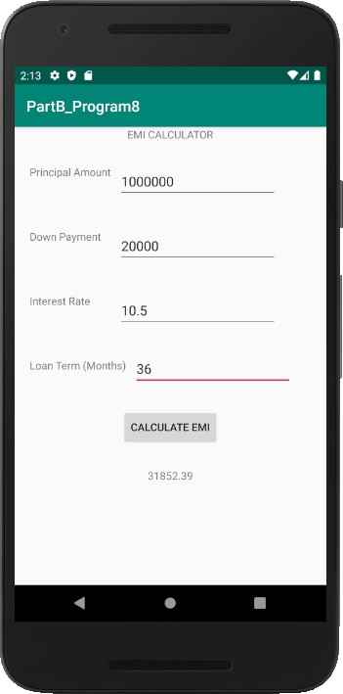
Sample Output

Reference Books

- Google Developer Training, "Android Developer Fundamentals Course – Concept Reference”, Google Developer Training Team, 2017. https://www.gitbook.com/book/google-developer-training/android-developer- fundamentals-course-concepts/details
(Download pdf file from the above link)
- Erik Hellman, “Android Programming – Pushing the Limits”, 1st Edition, Wiley India Pvt Ltd, 2014. ISBN-13: 978-8126547197
- Dawn Griffiths and David Griffiths, “Head First Android Development”, 1st Edition, O‟Reilly SPD Publishers, 2015. ISBN-13: 978-9352131341
- Bill Phillips, Chris Stewart and Kristin Marsicano, “Android Programming: The Big Nerd Ranch Guide”, 3rd Edition, Big Nerd Ranch Guides, 2017. ISBN-13: 978-0134706054

